What is guaranteed to be printed by the following code?

Int[] array = {6, 9, 8}

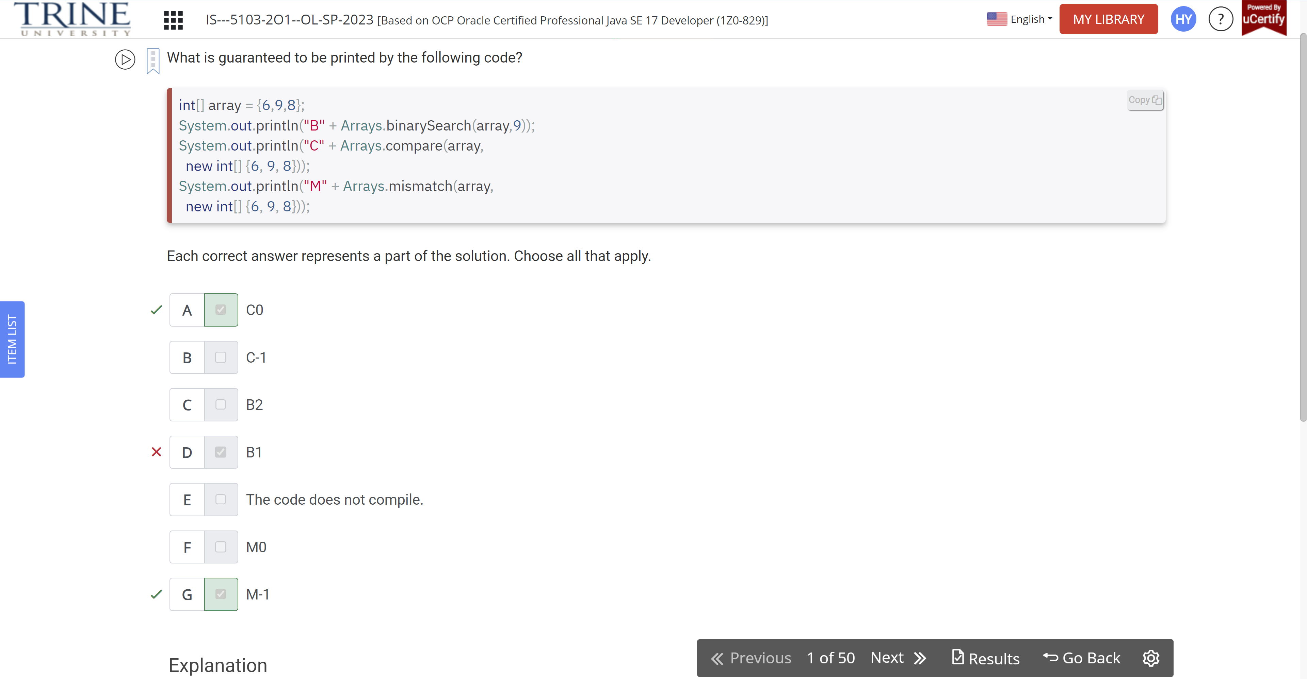

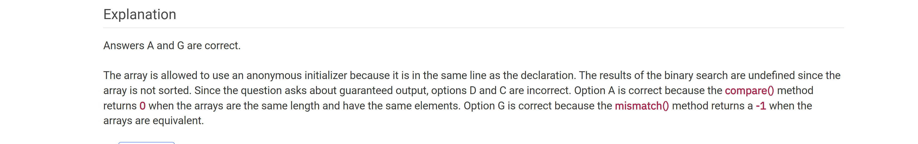

How many times is the word true printed?

Var s1 = “Java”

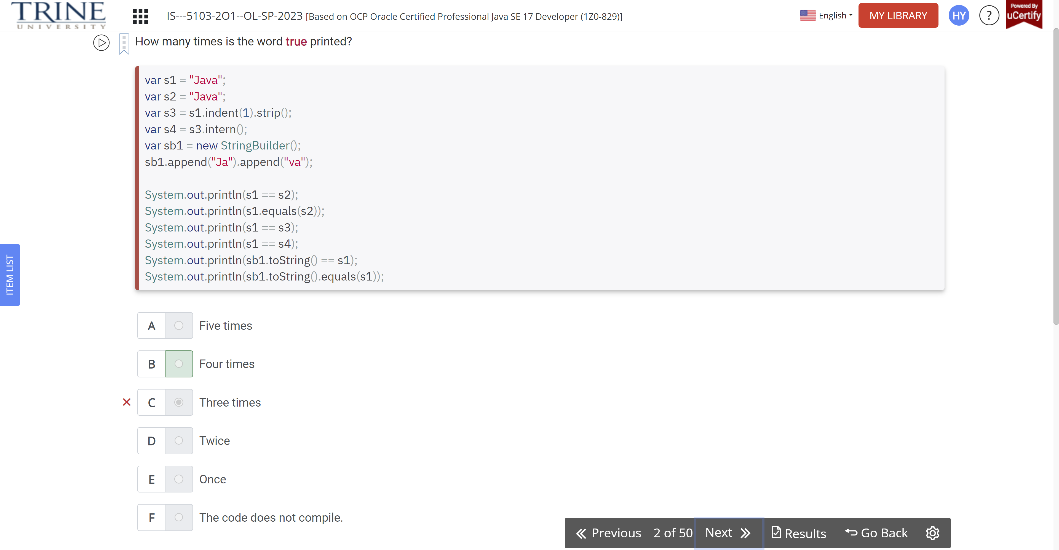

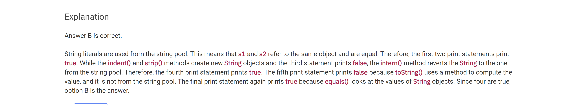

If all four of these files exist, which would be chosen when asking for English US?

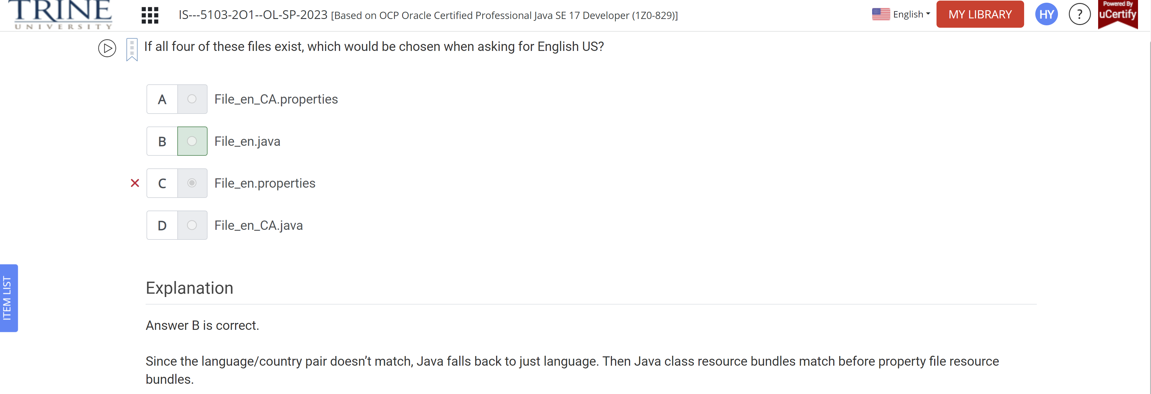

What is the output of the following program?

Class Deer {}

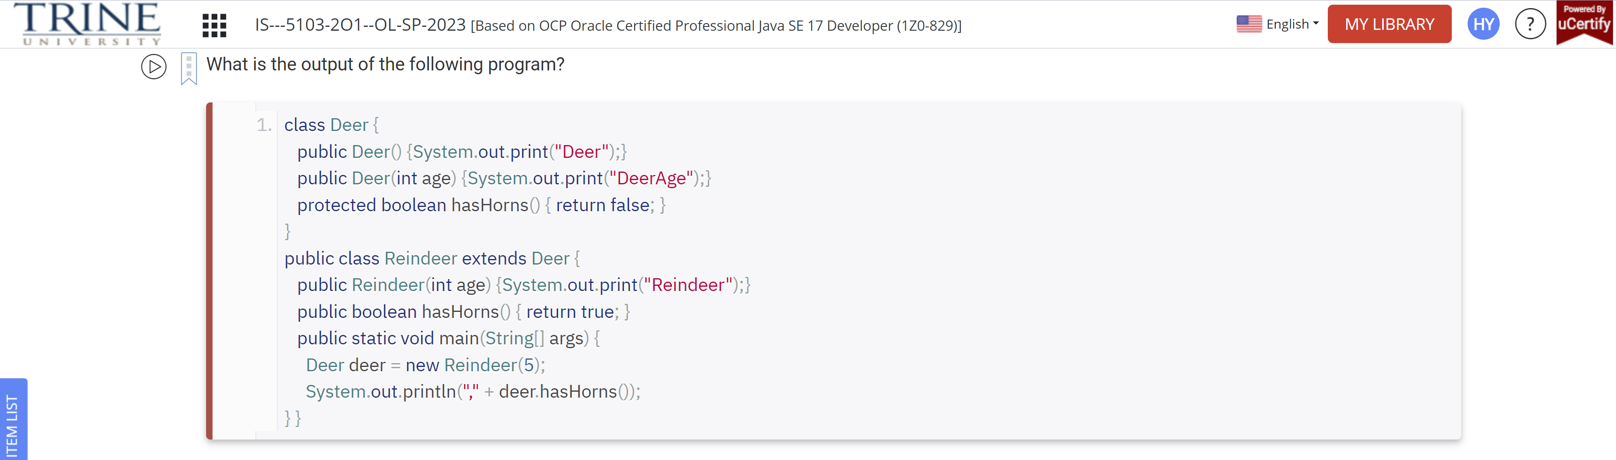

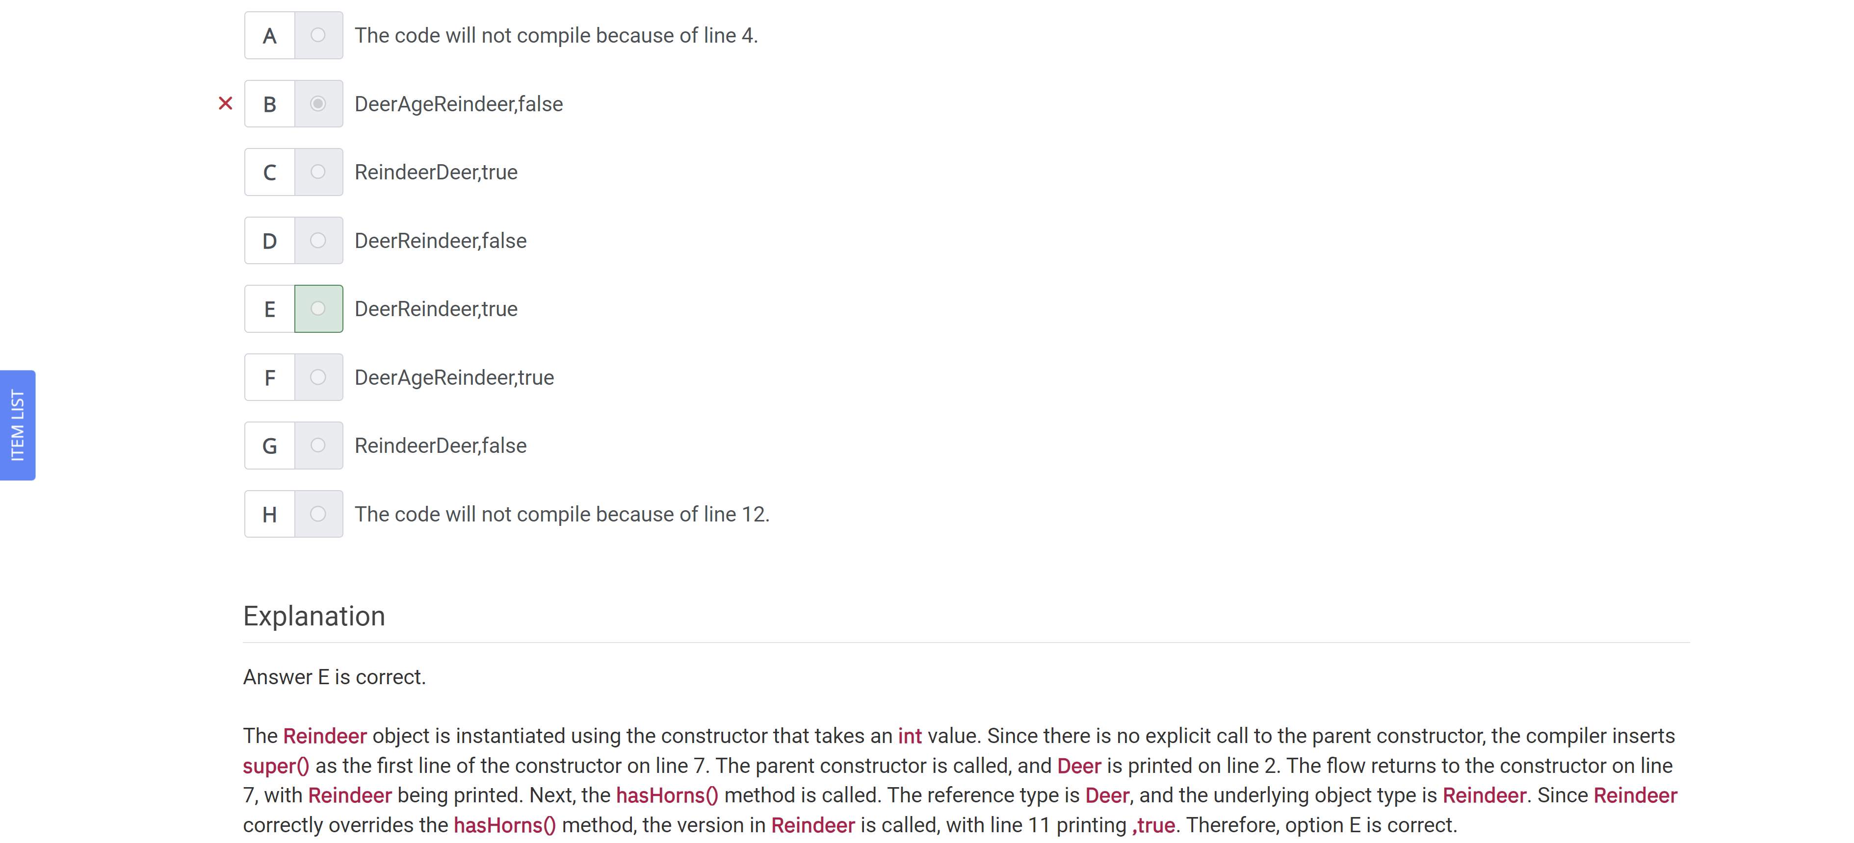

Which lines in Tadpole.java give a compiler error?

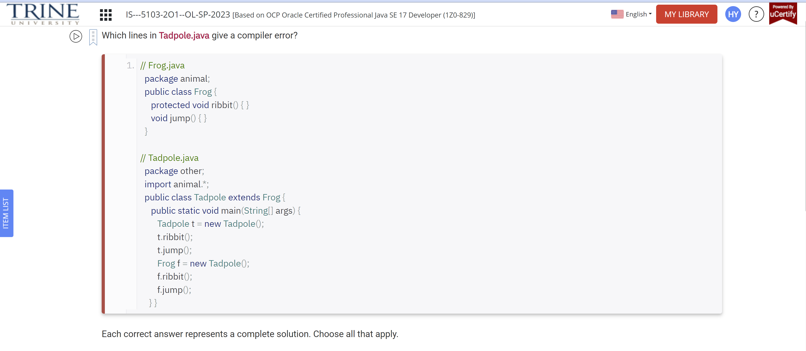

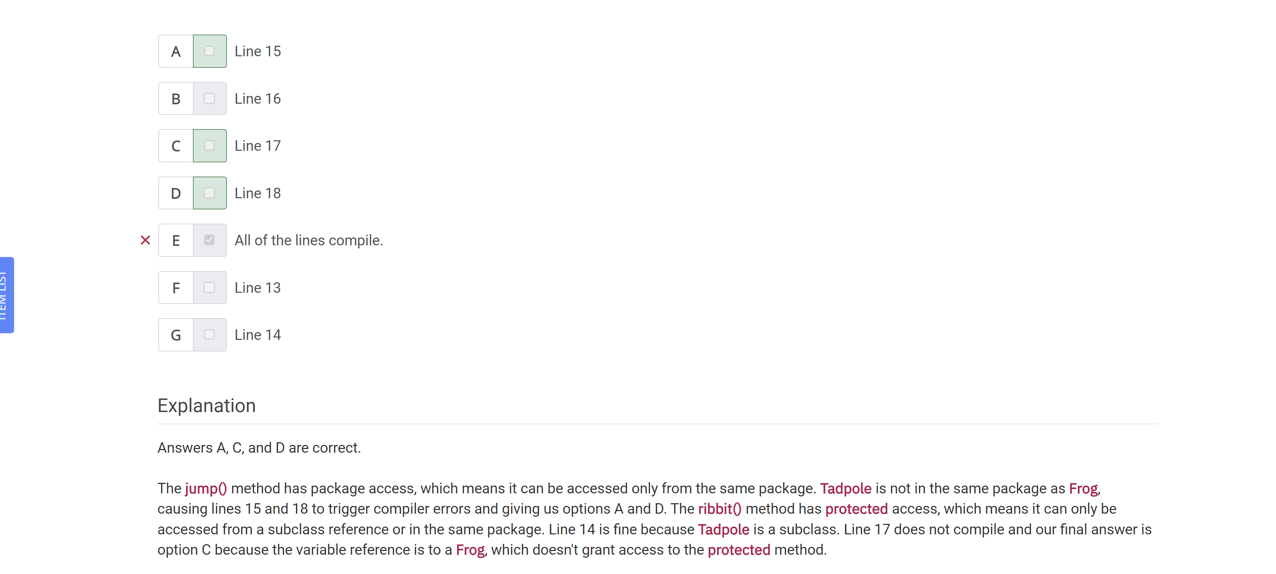

What is the result of the following program?

Public class MathFunctions {}

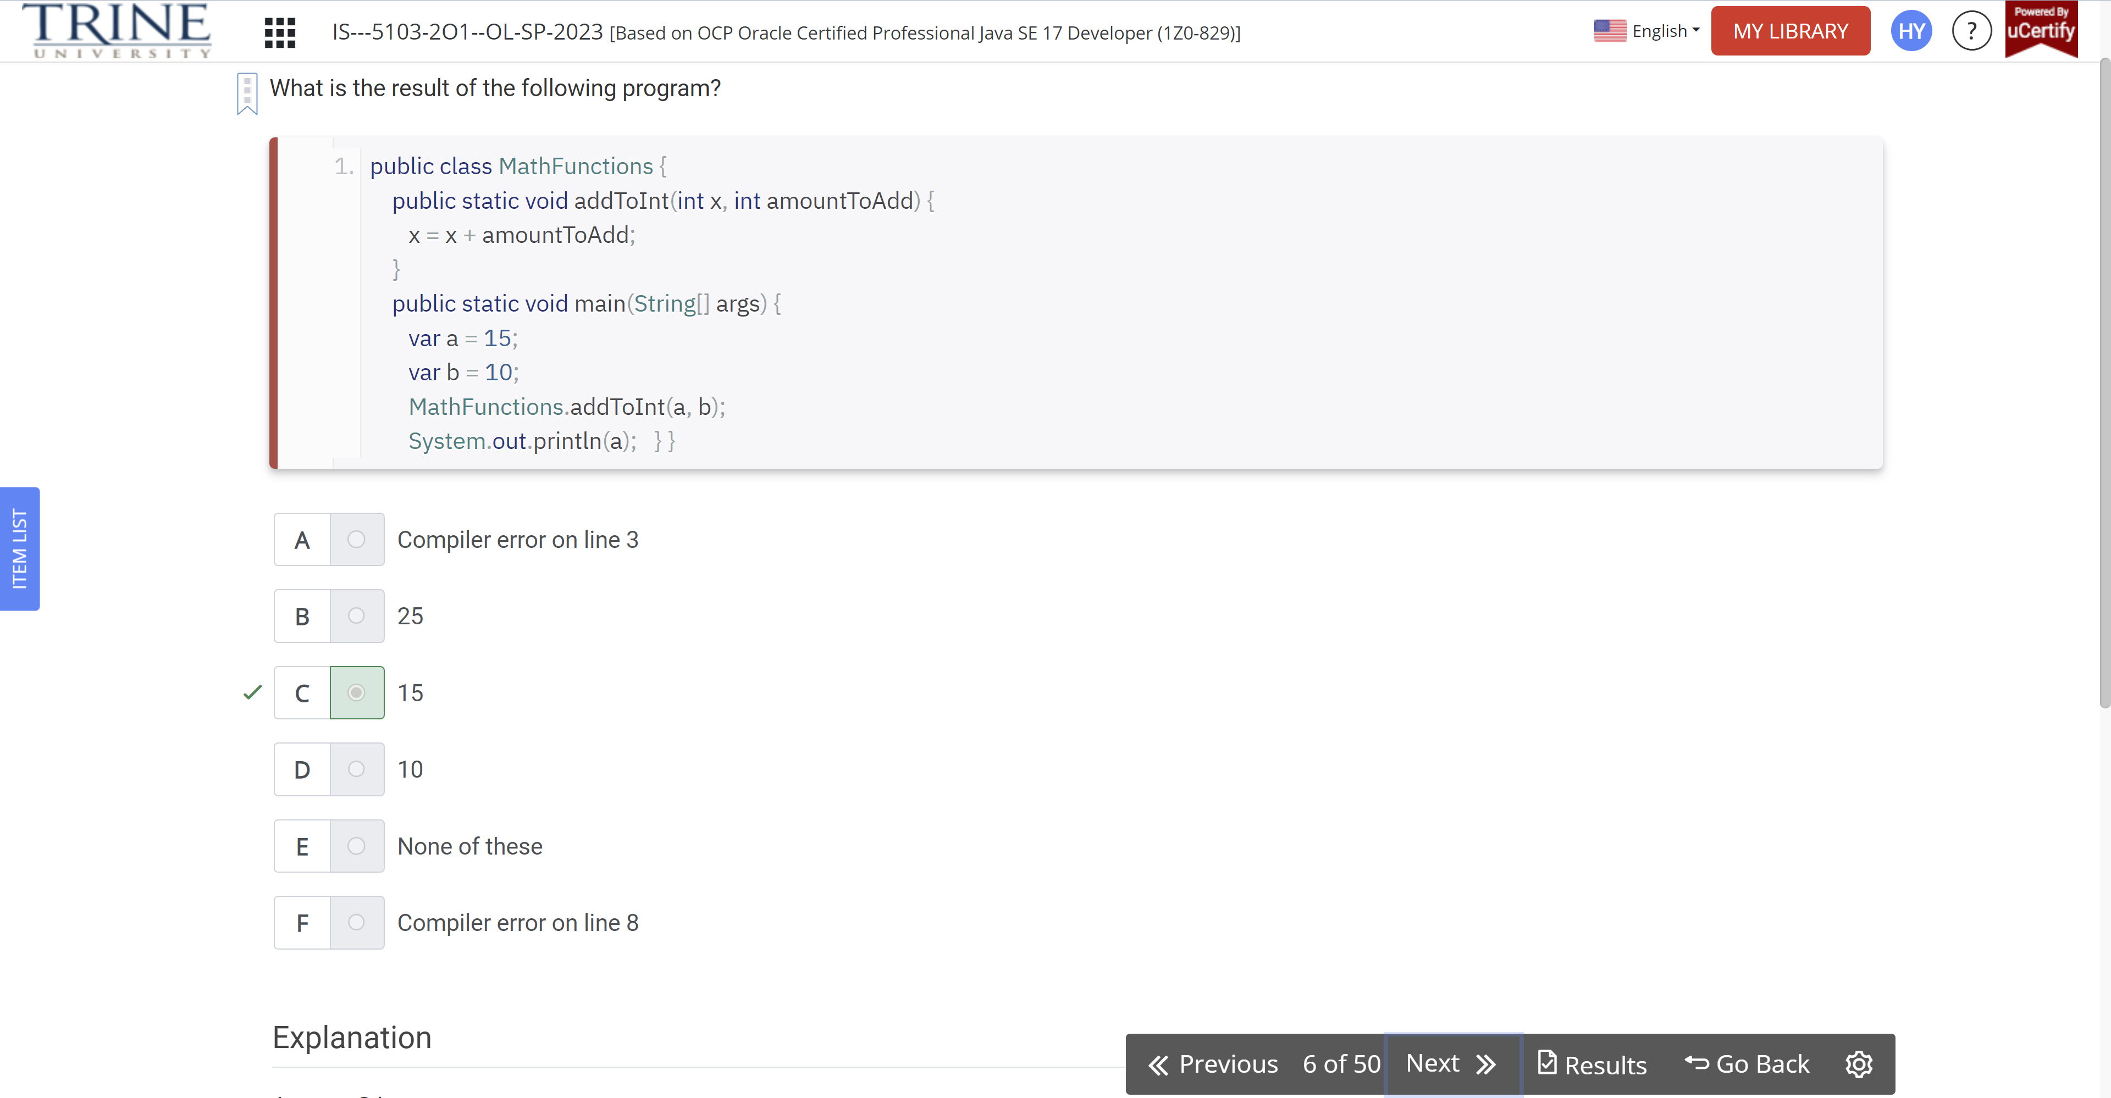

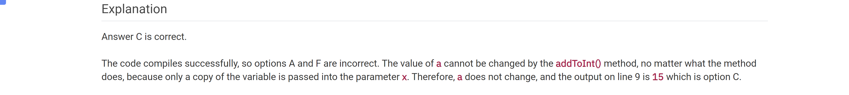

Which of the following is a valid instance member of a class?

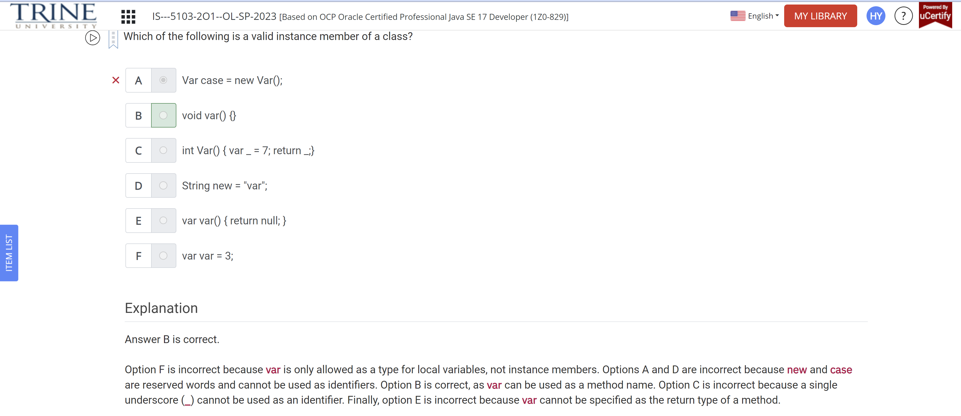

What is the output of the code?

Predicate<…

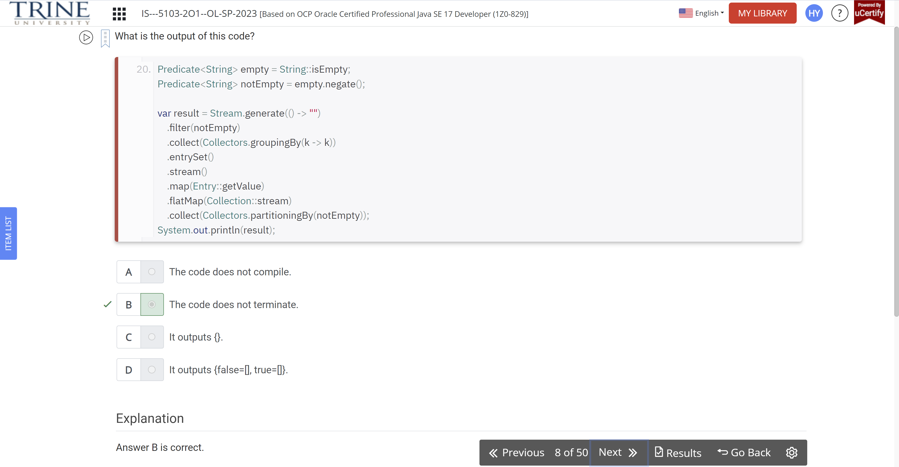

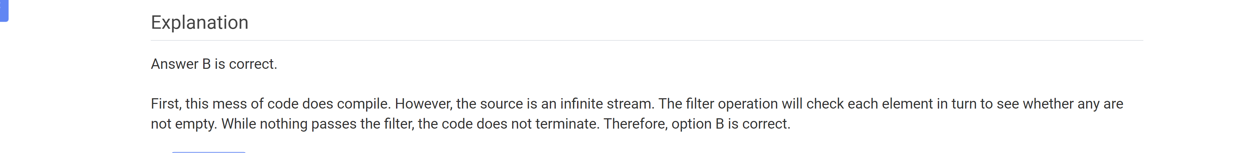

What is the name of the class used to delete a directory?

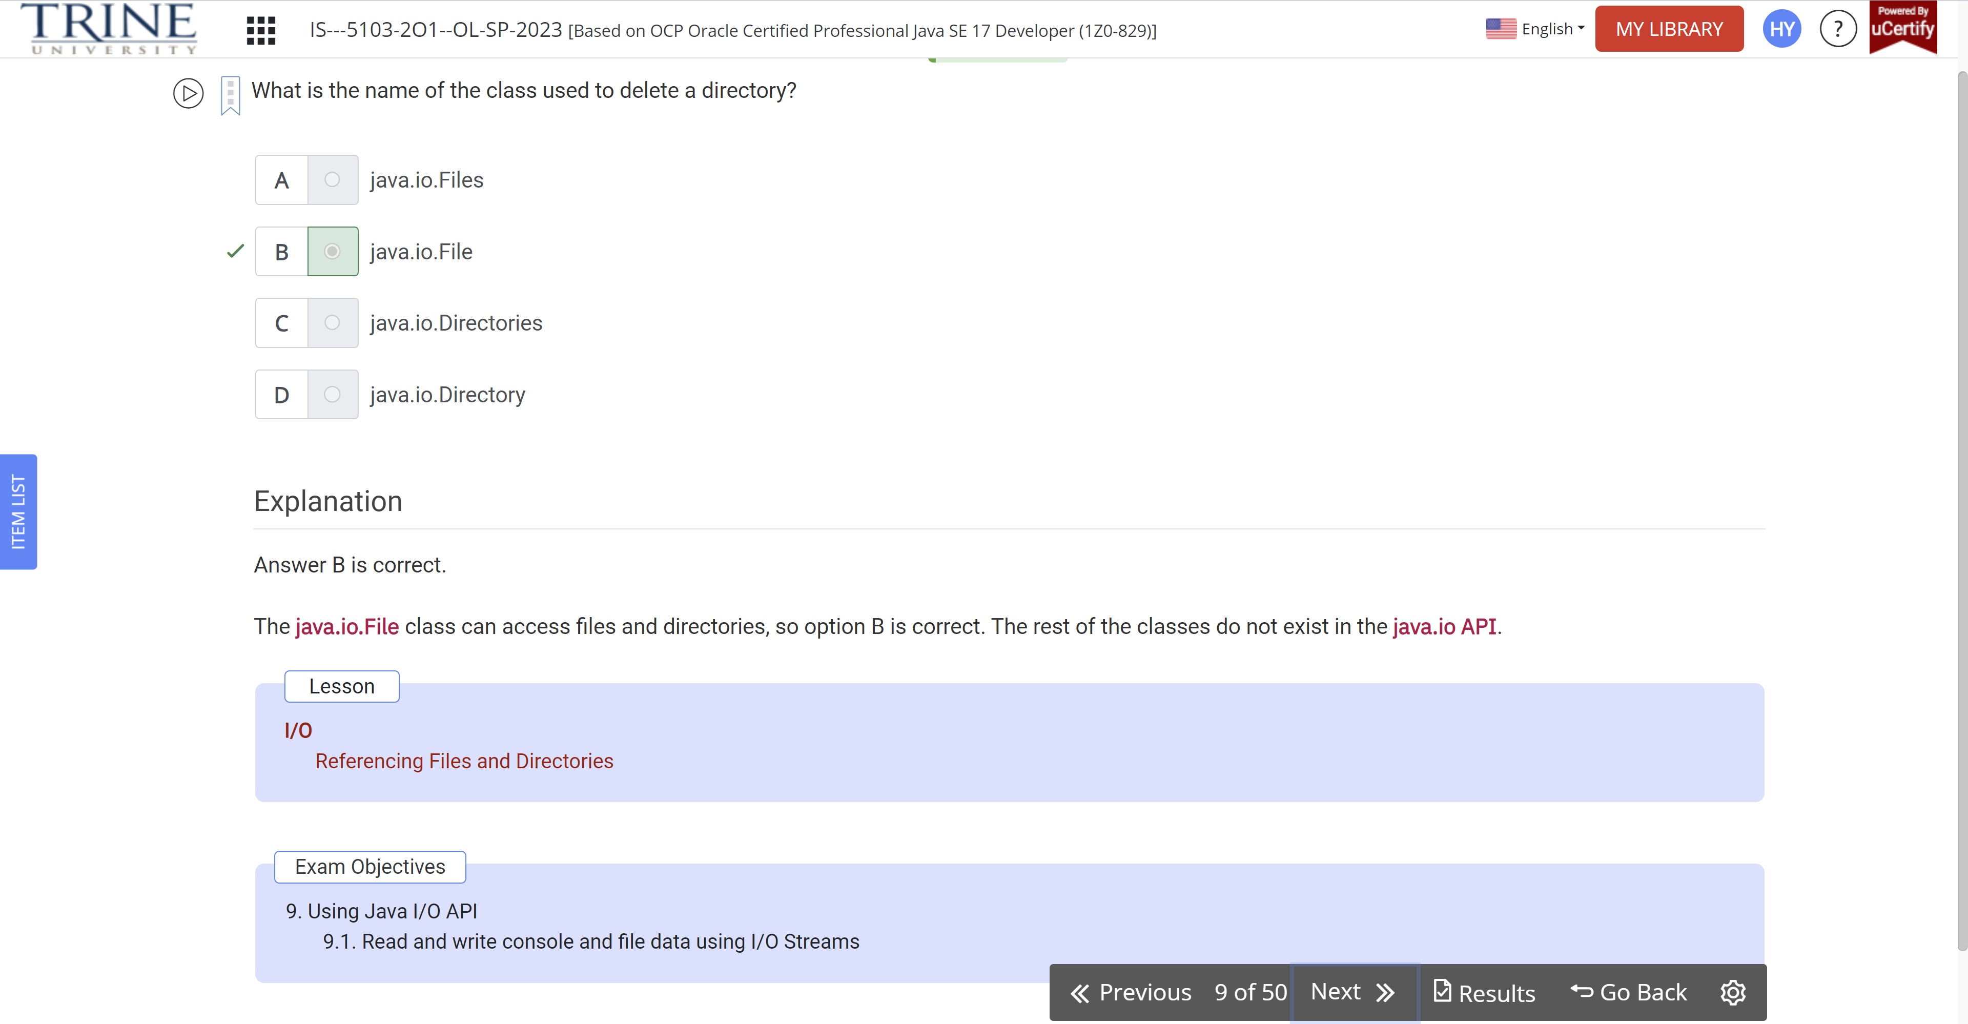

Which method must be called to properly terminate an OutputStream?

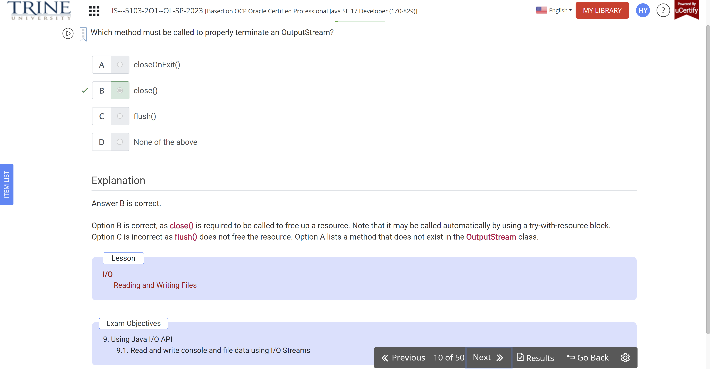

Which method defined in the Lock interface will return immediately if a lock cannot be obtained?

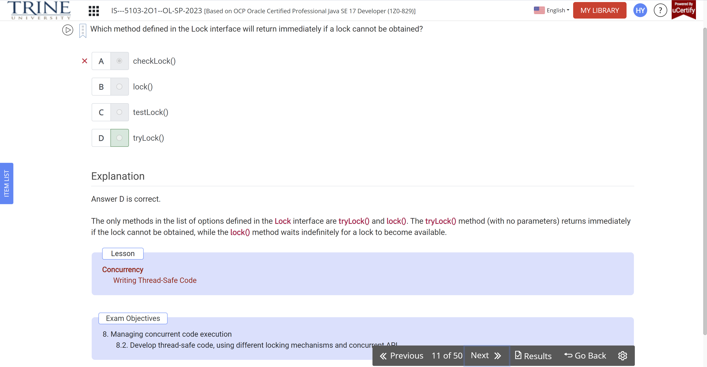

The body of a for loop must run at least 0 times

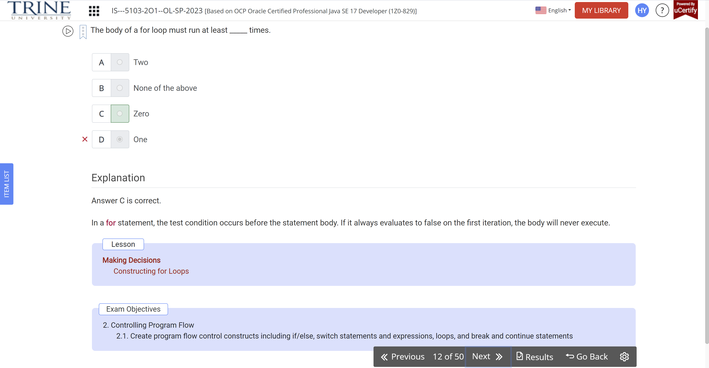

Which java.io class would be best to use to write text data to a user?

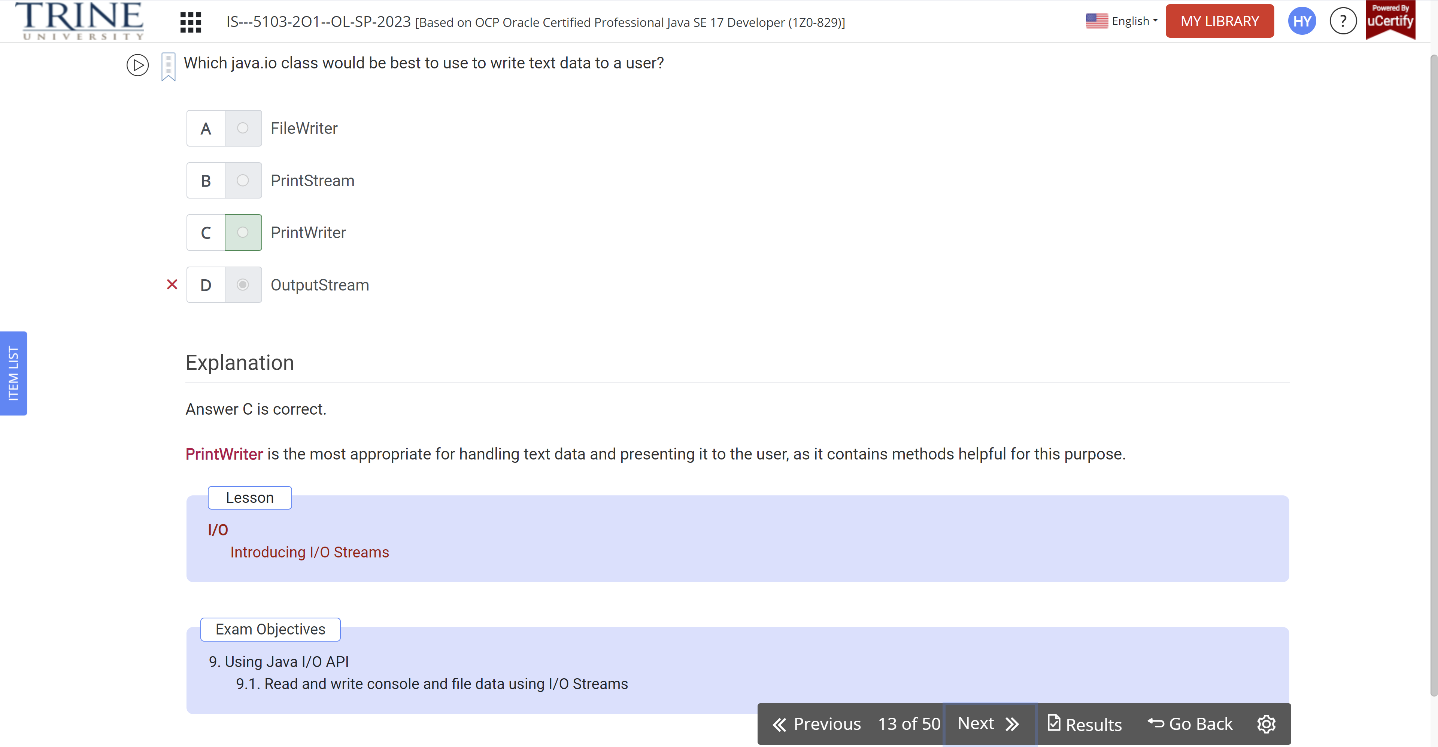

Assuming the following declarations are top-level types declared in the same file, which of these will successfully compile

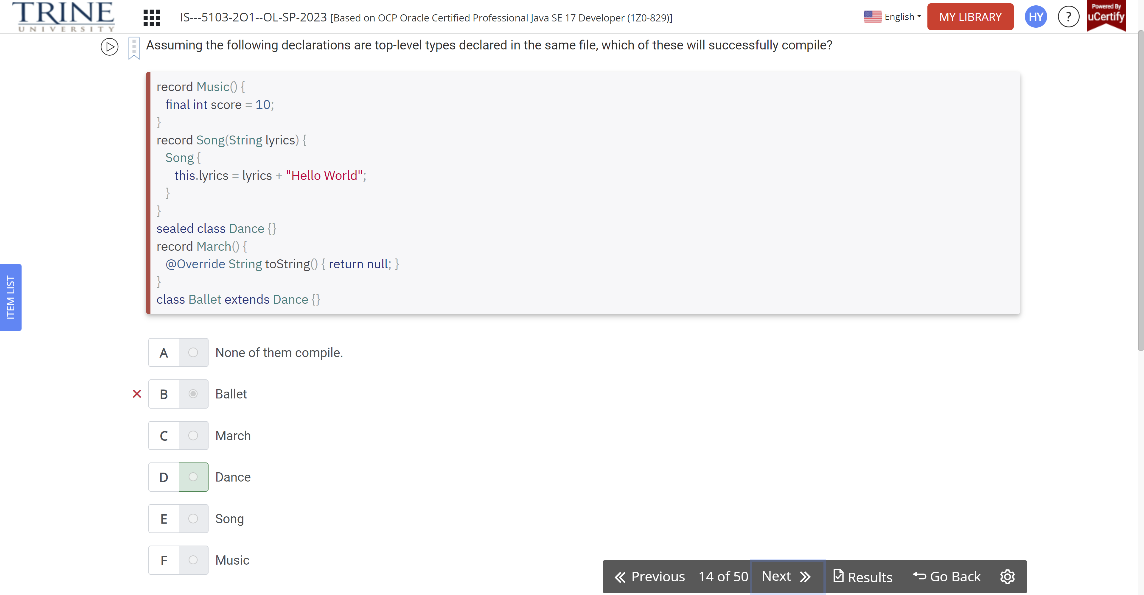

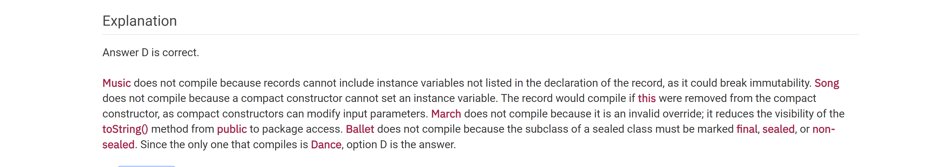

An __ module always contains …

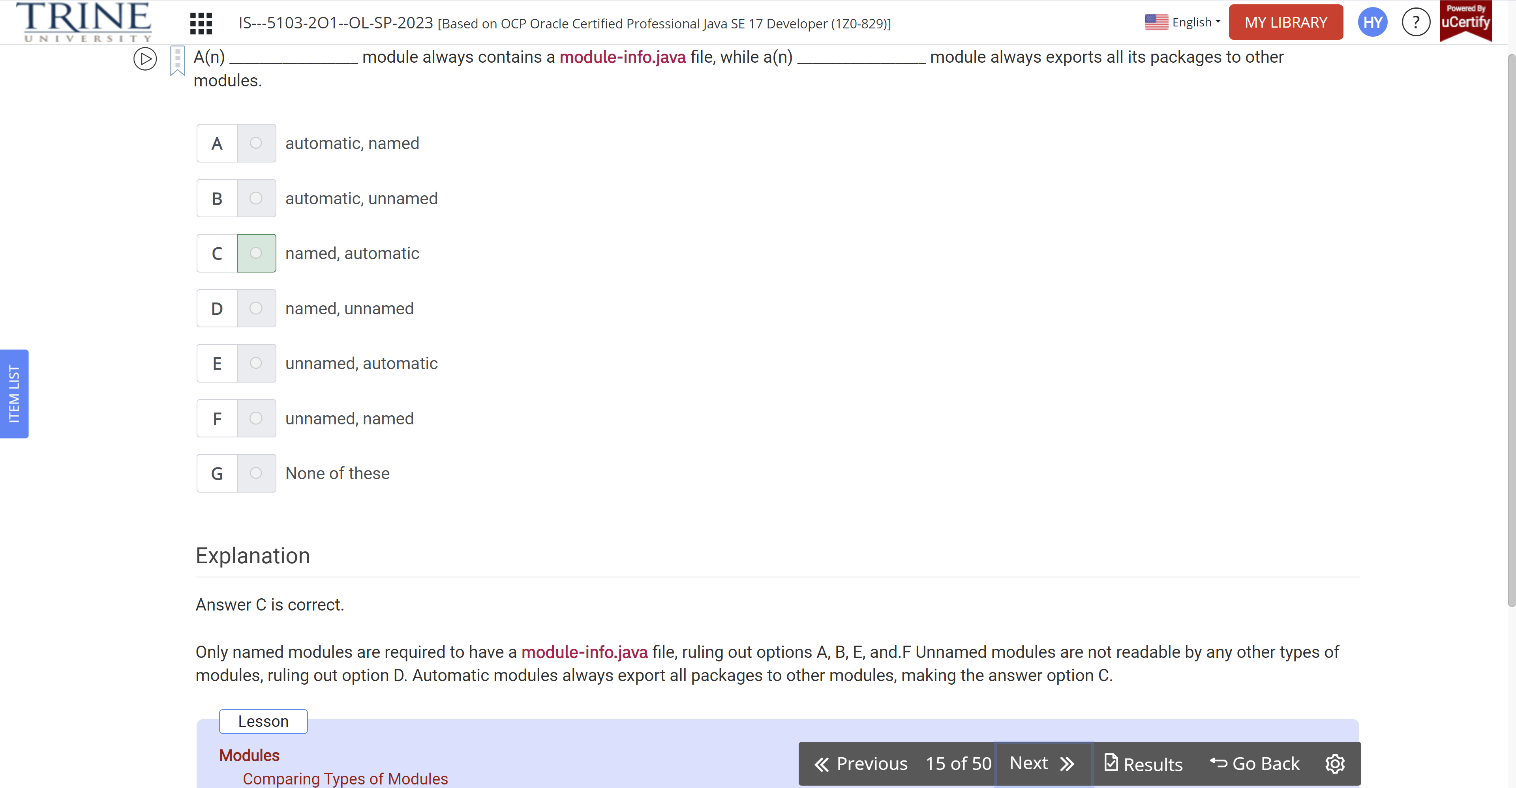

Which changes , when made independently, guarantee the following code snippet prints 100 at runtime?

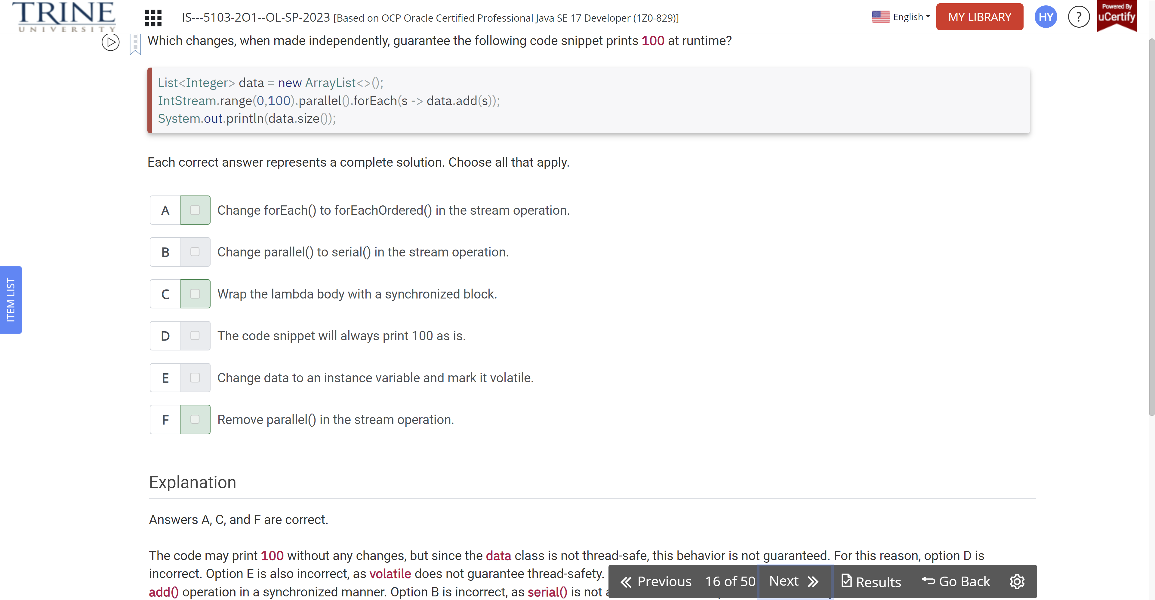

Which of the following are true

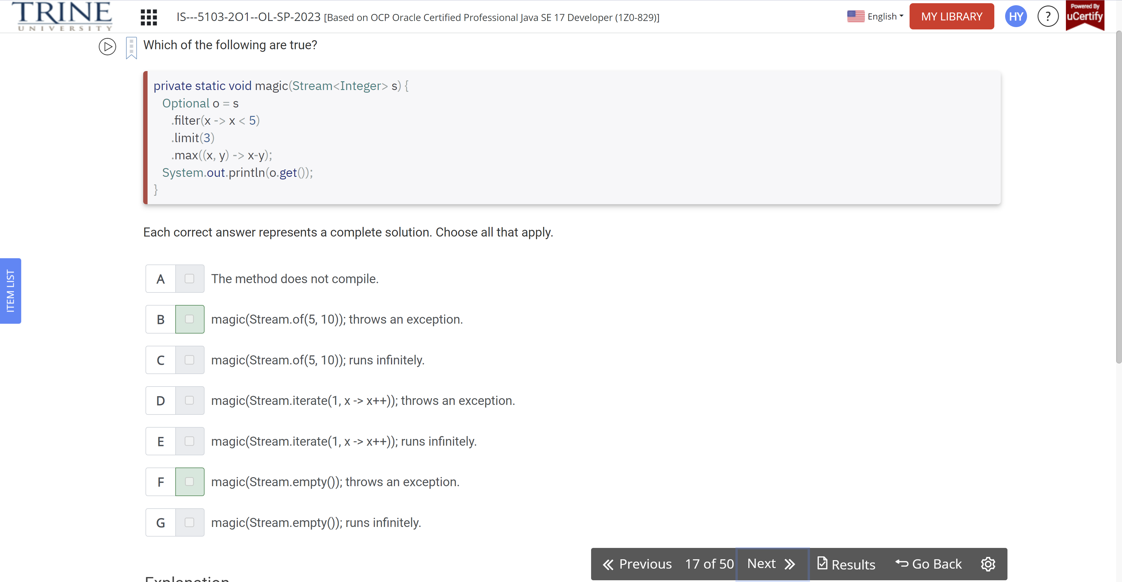

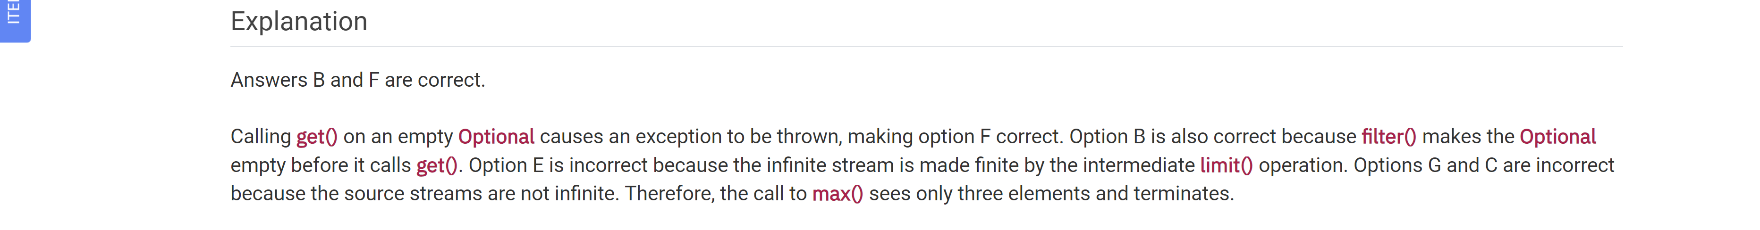

What interface is used to call a stored procedure?

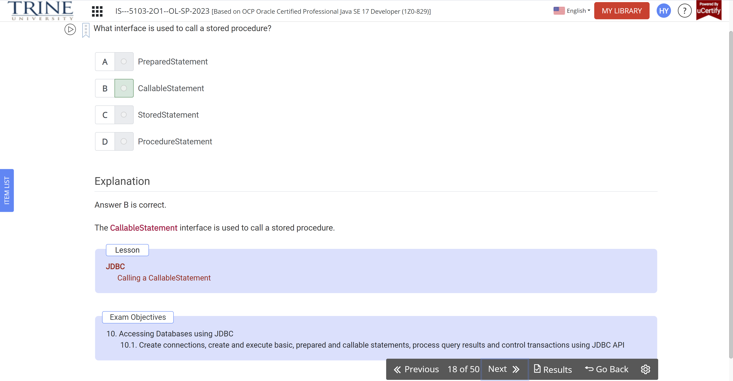

What is the result of executing the following code snippet?

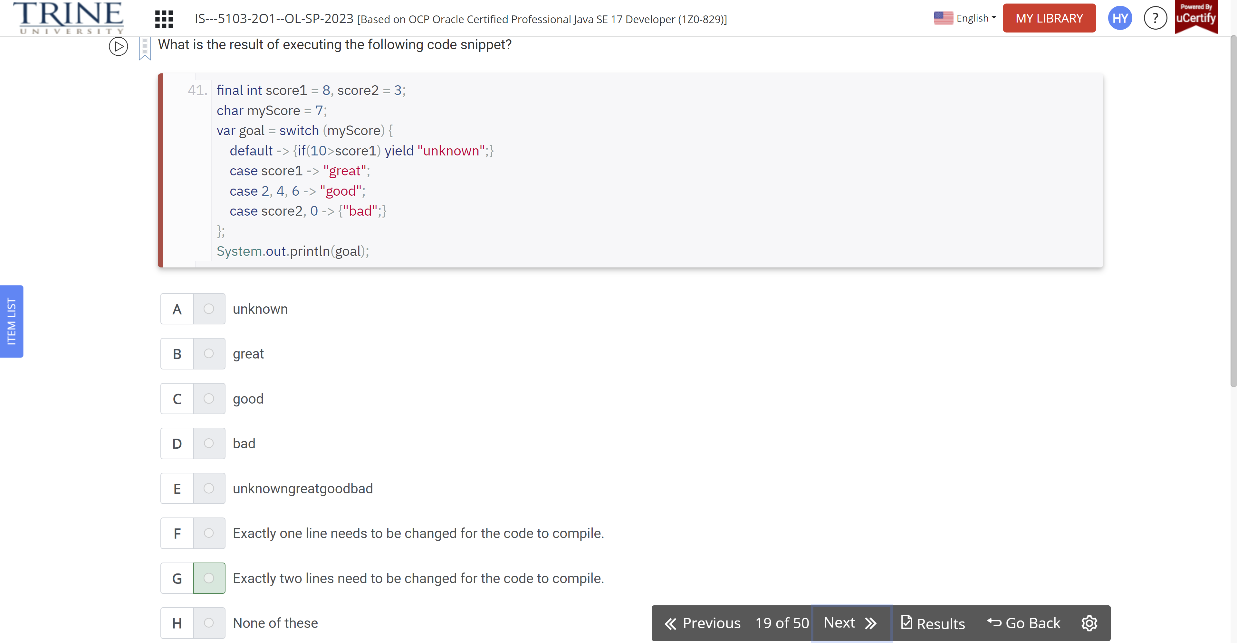

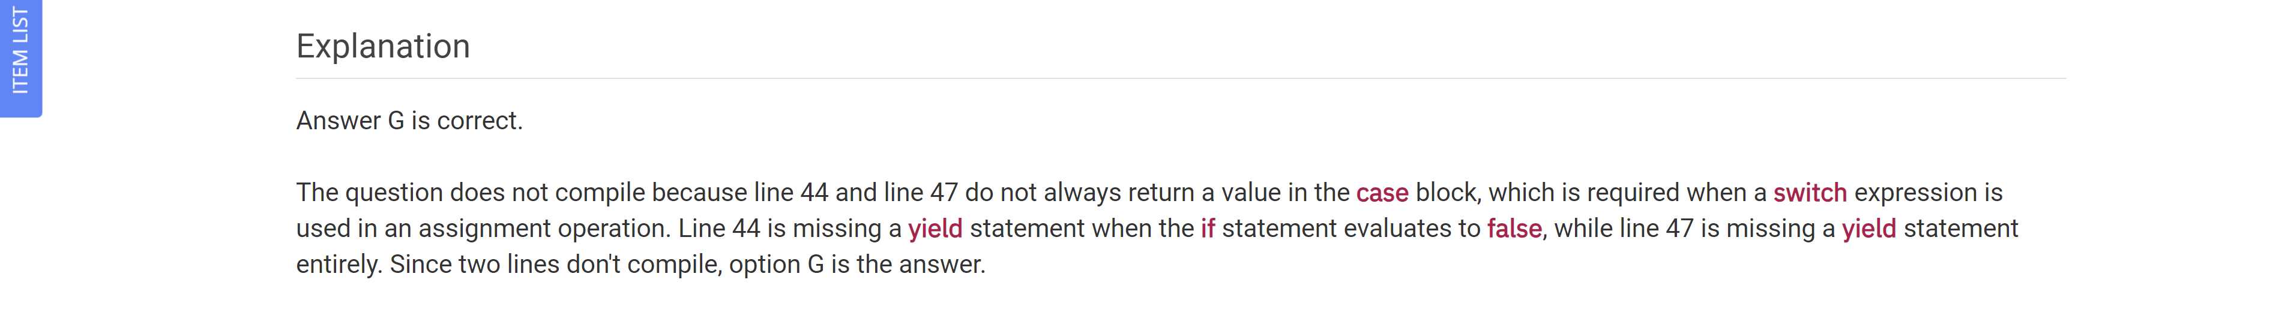

What is the result of the following code?

Var treeMap = ..

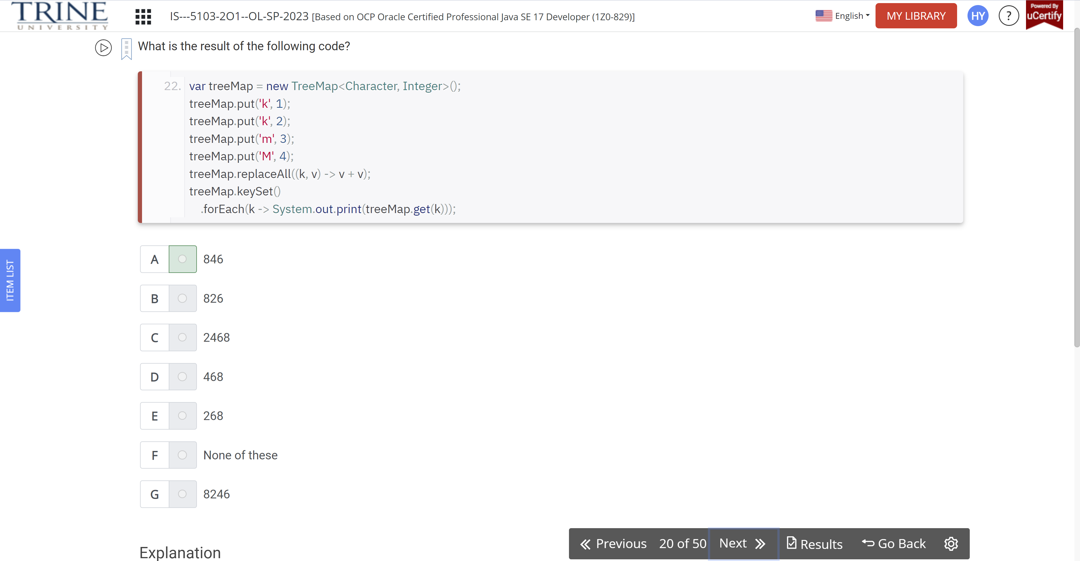

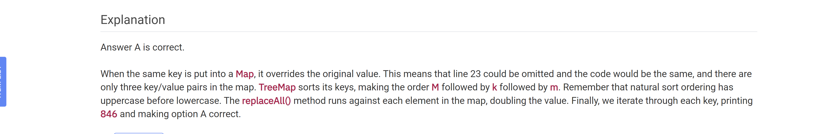

Suppose that we have the following property files and code. What values…

Penguin.properties

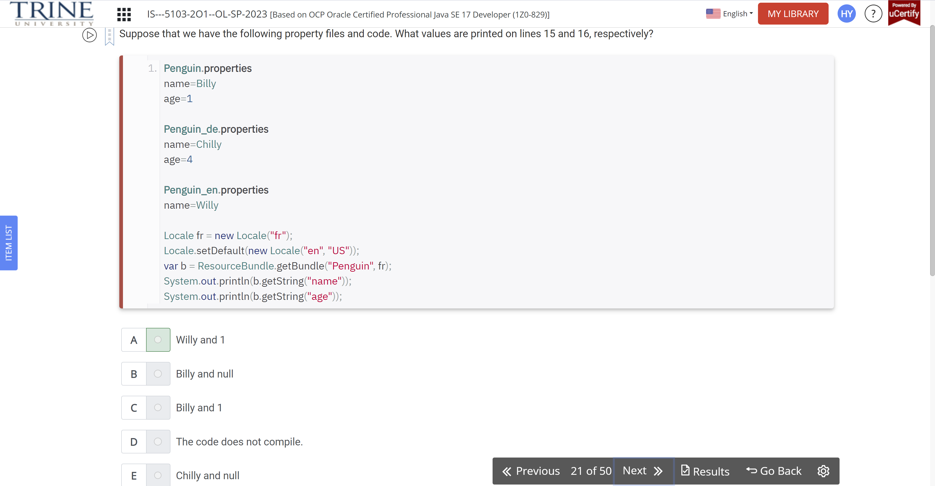

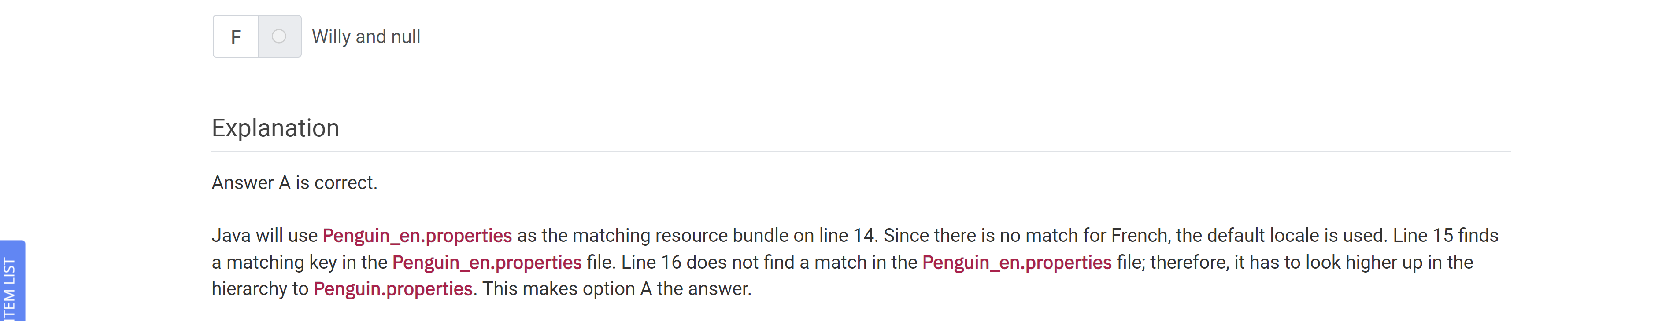

In order of all loops (with no break/continue…

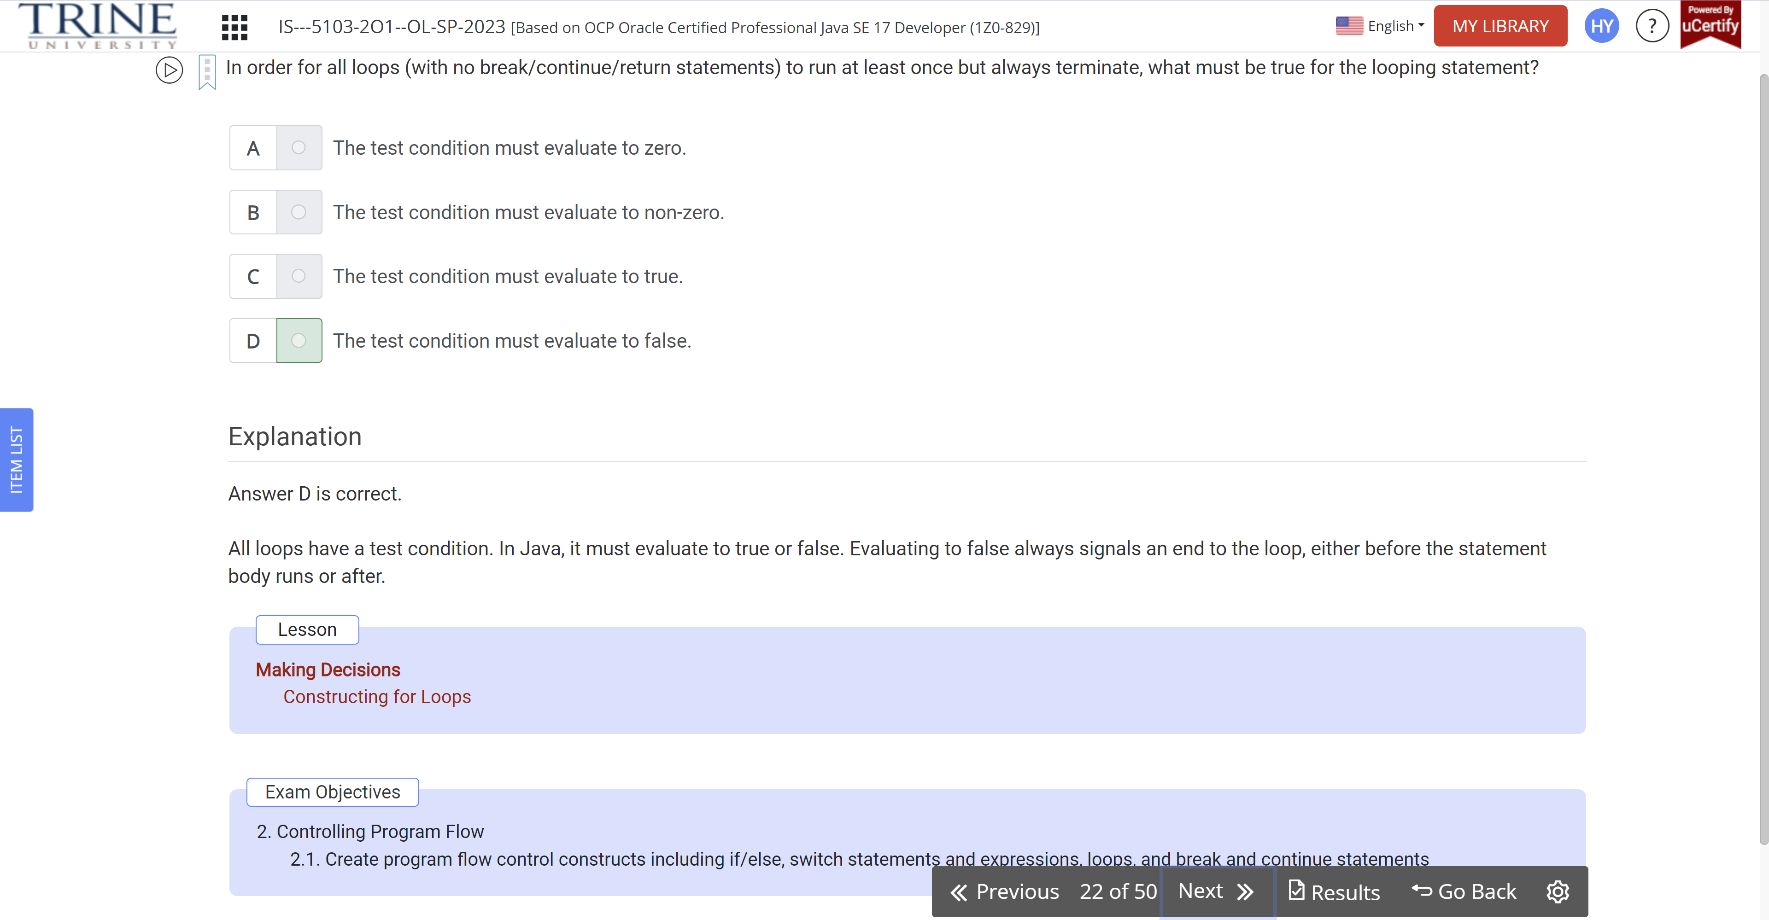

Which functional interfaces complete the following code, presuming variable r exists?

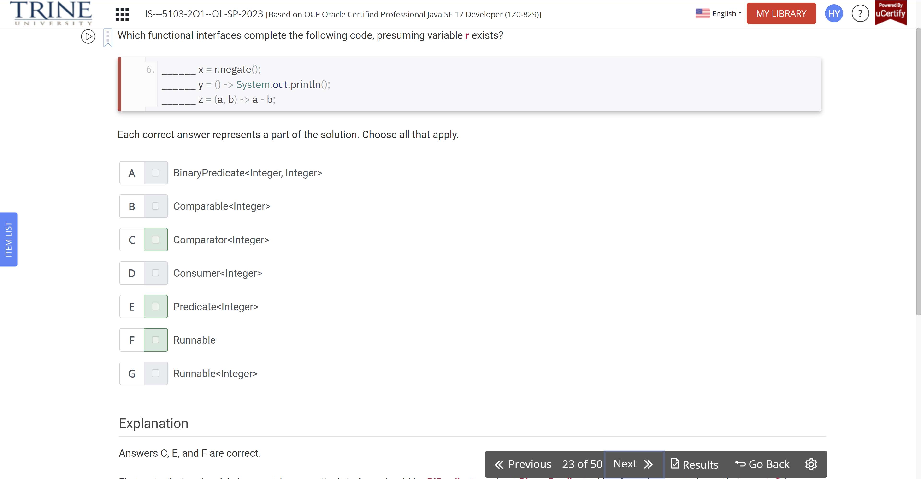

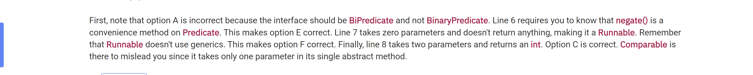

What is the result of executing the following application?

Final var cb = new CyclicBarrier(…

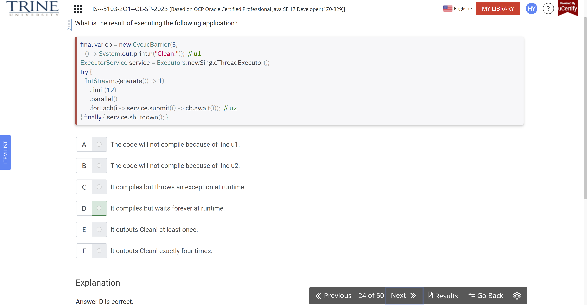

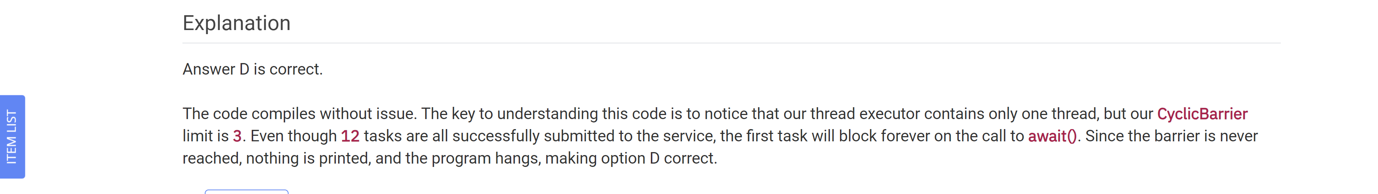

Which of the following defines an infinite loop execution?

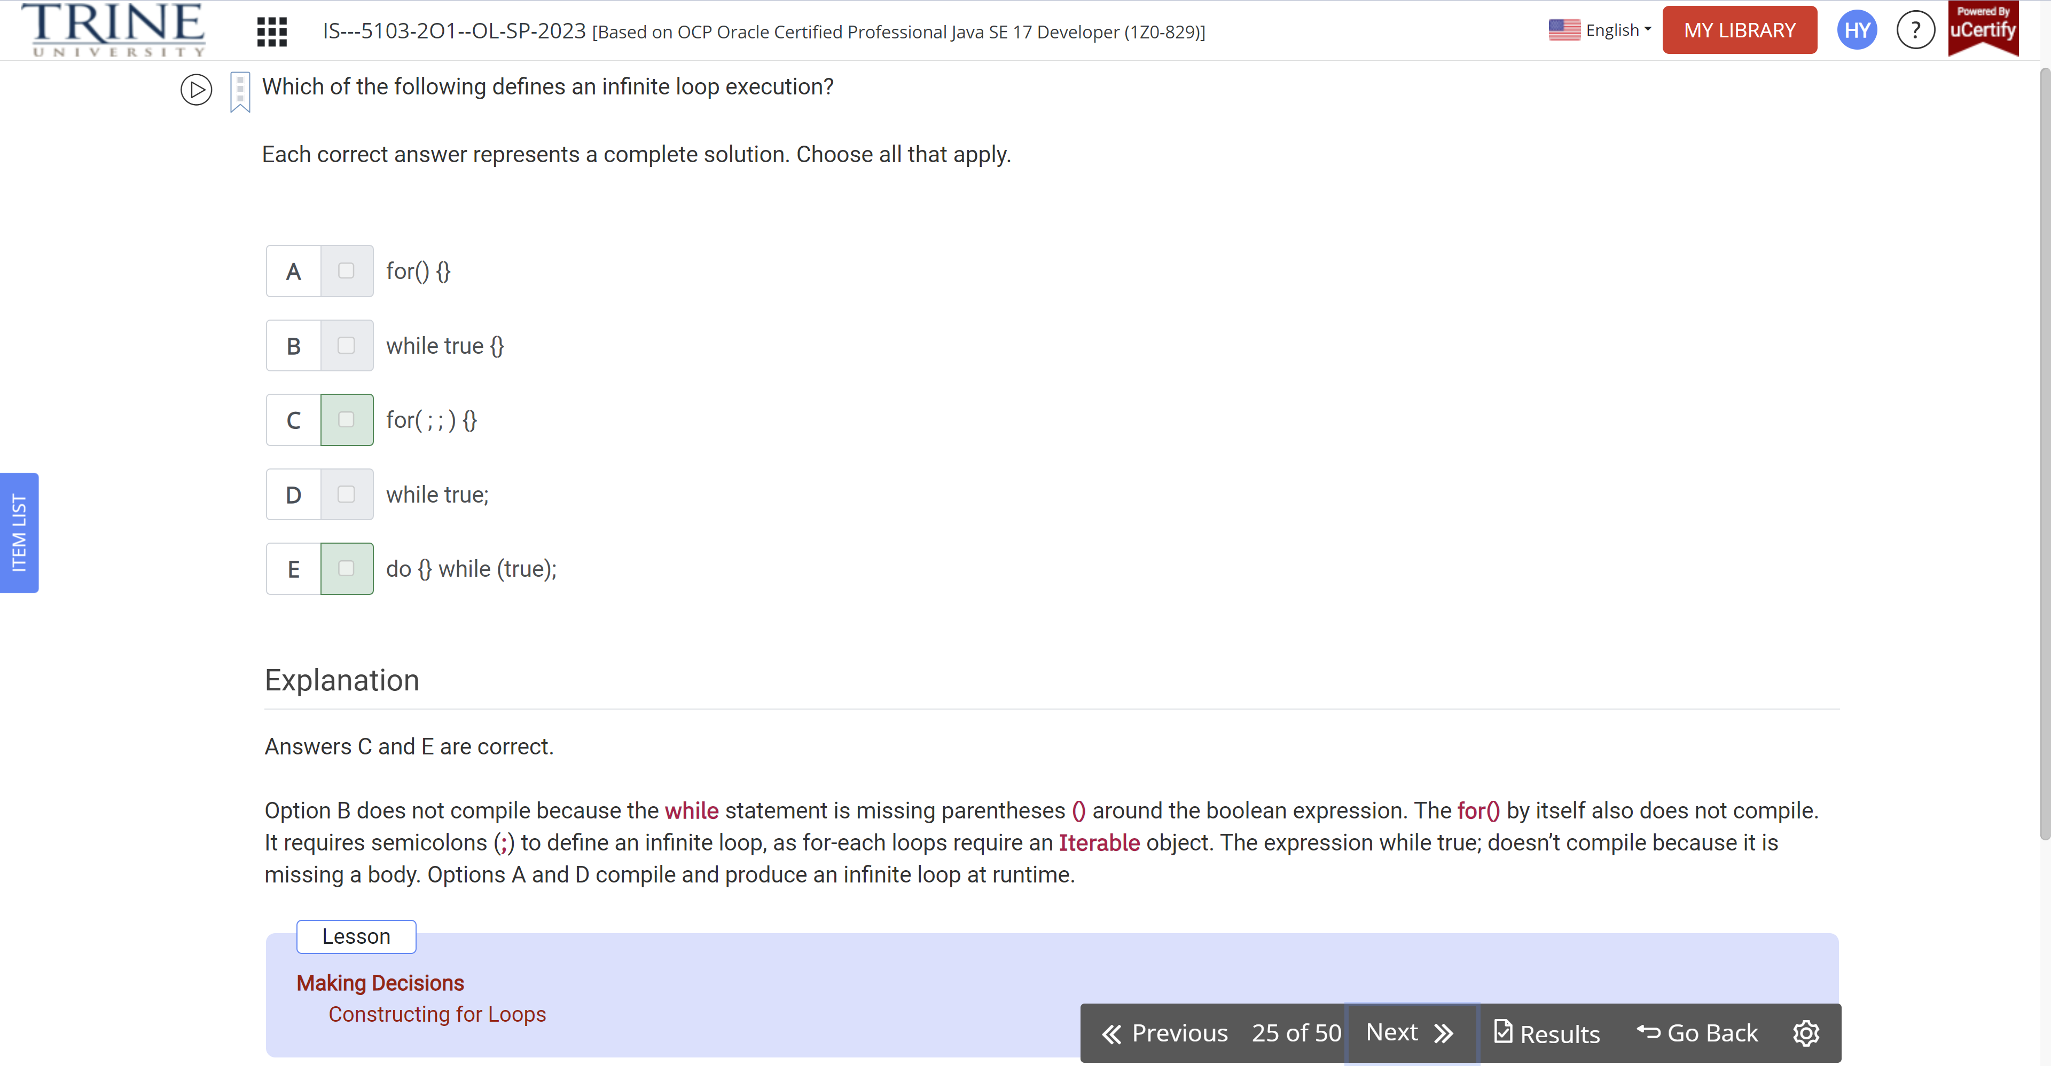

When printed, which String gives the same value as this text book?

Var pooh = “””…

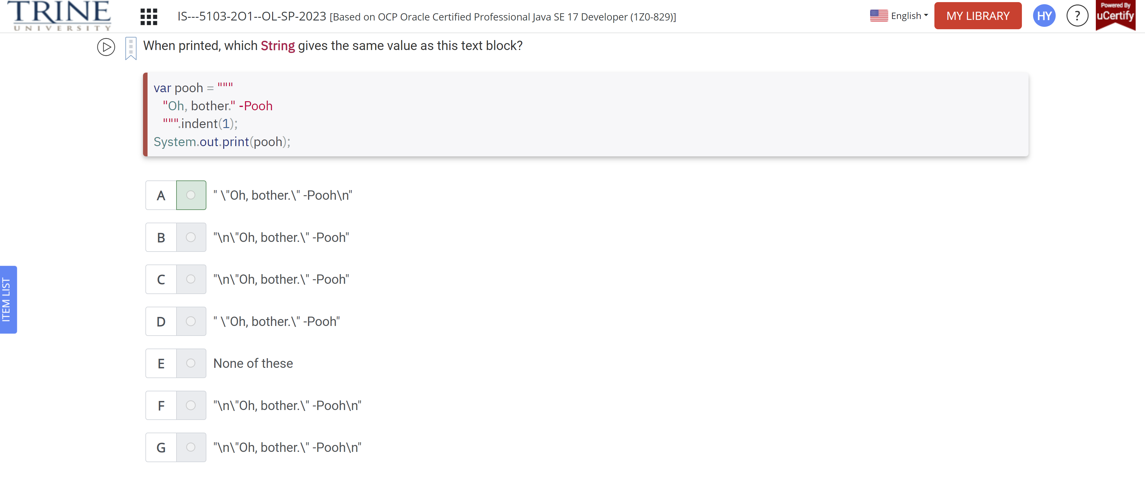

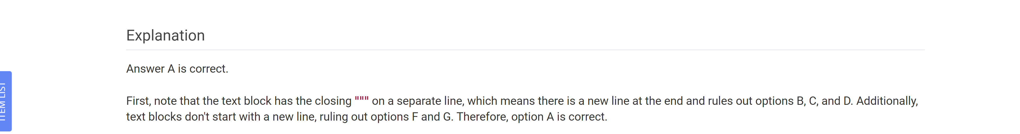

Which is true if the contents of path1 start with the text Howdy?

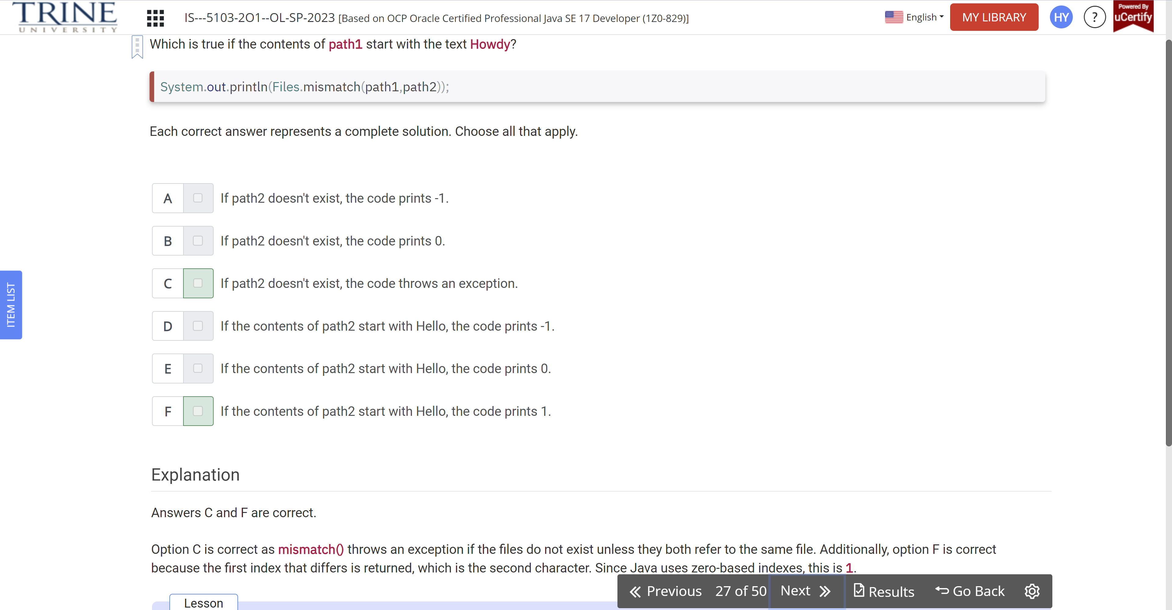

What is the output of the following code snippet?

Int moon = 9, start=2+2+..

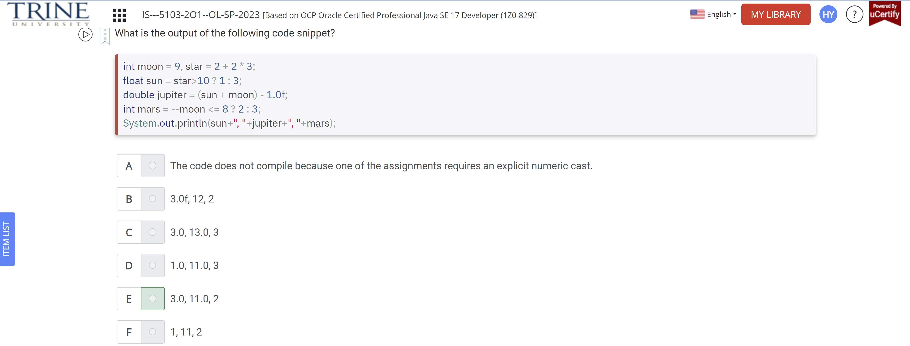

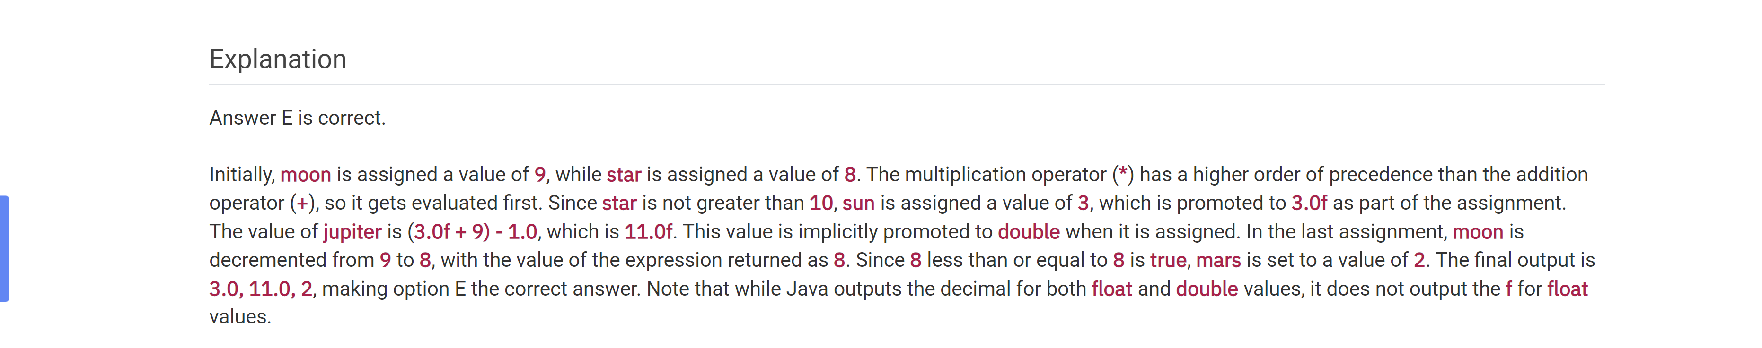

When creating a Locale, the country comes before the language,

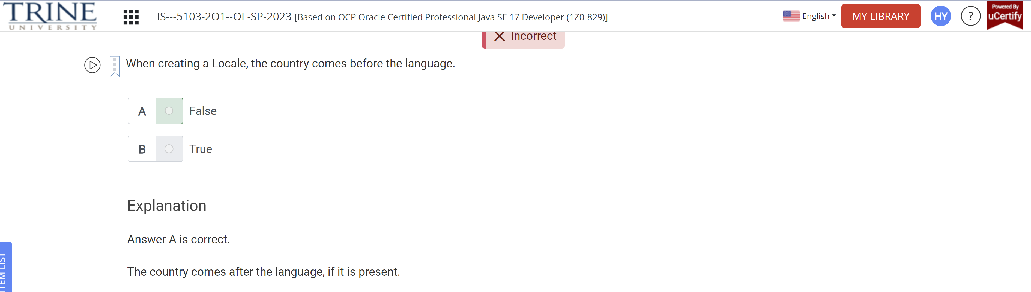

Which method can be used to create a task that repeats 10 seconds after the end of a previous task?

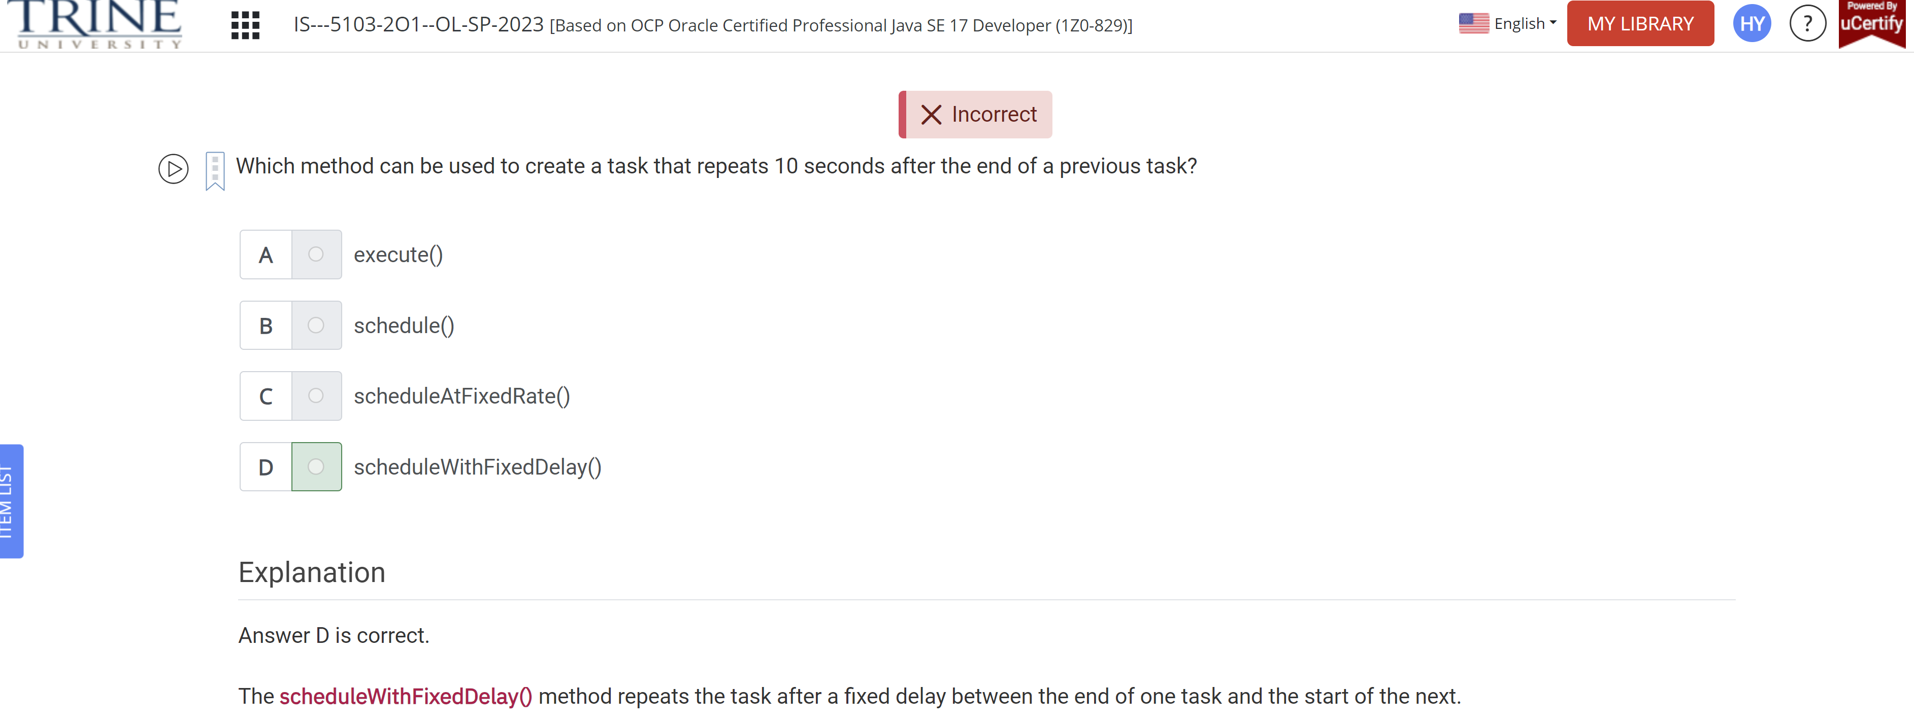

What is the output of the following program?

Interface HasTail {}

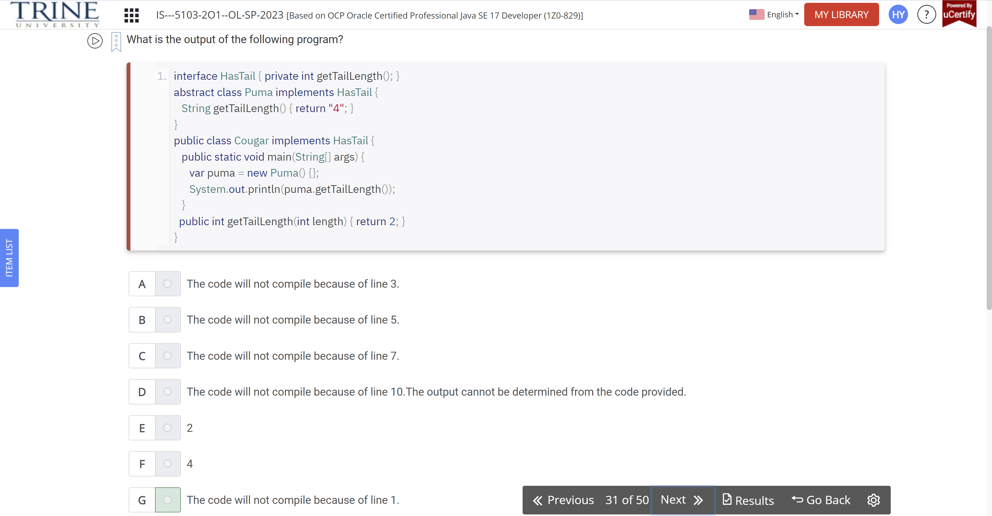

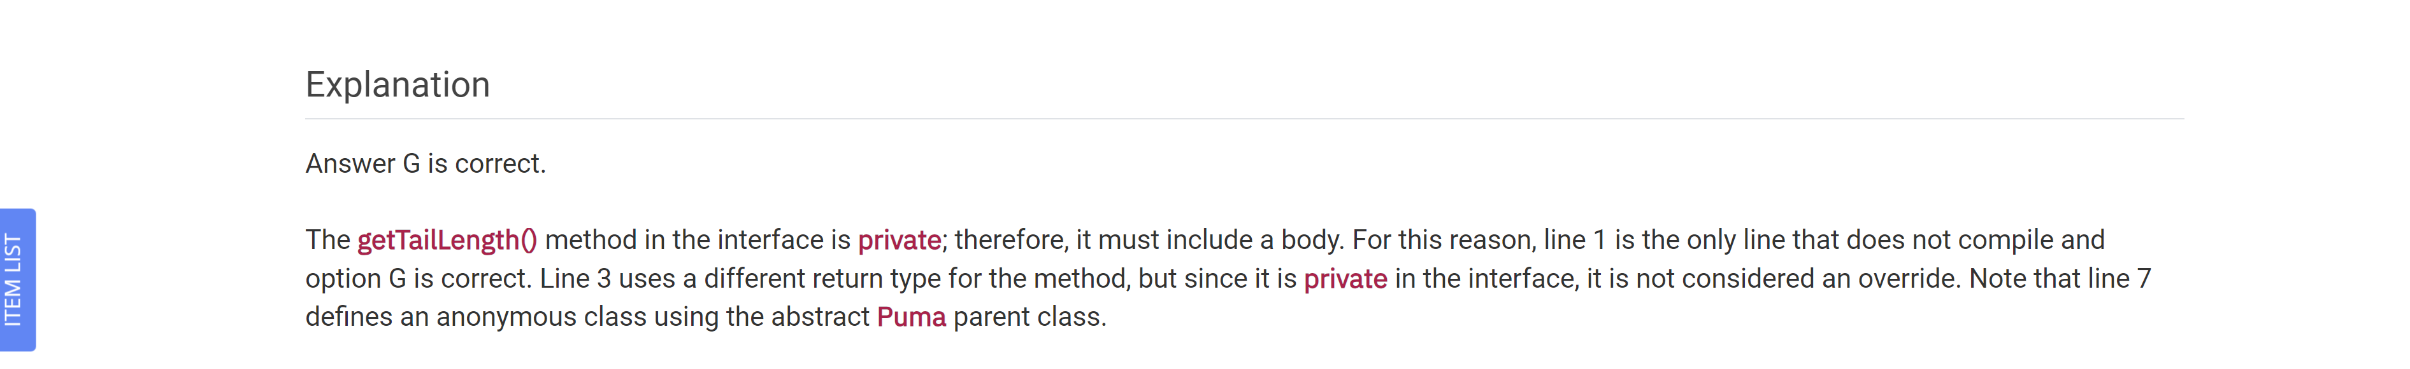

What exception is thrown when there is an issue connecting to the database?

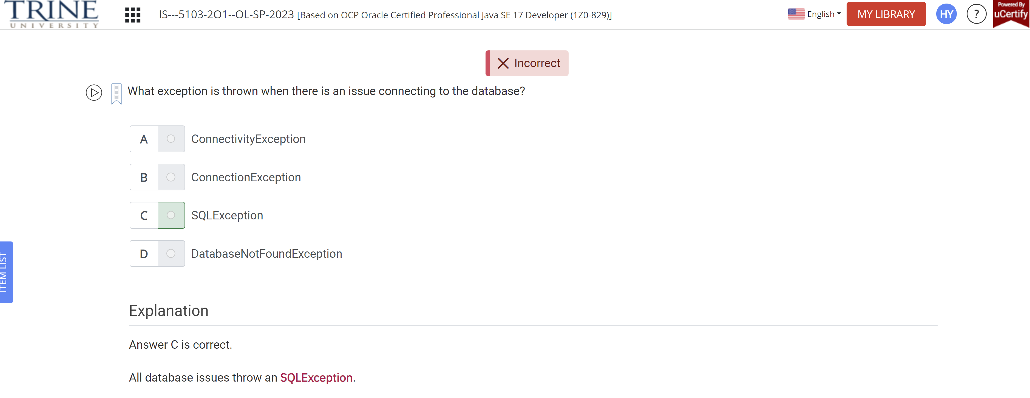

Which NIO.2 Path method allows you to join one Path to another Path?

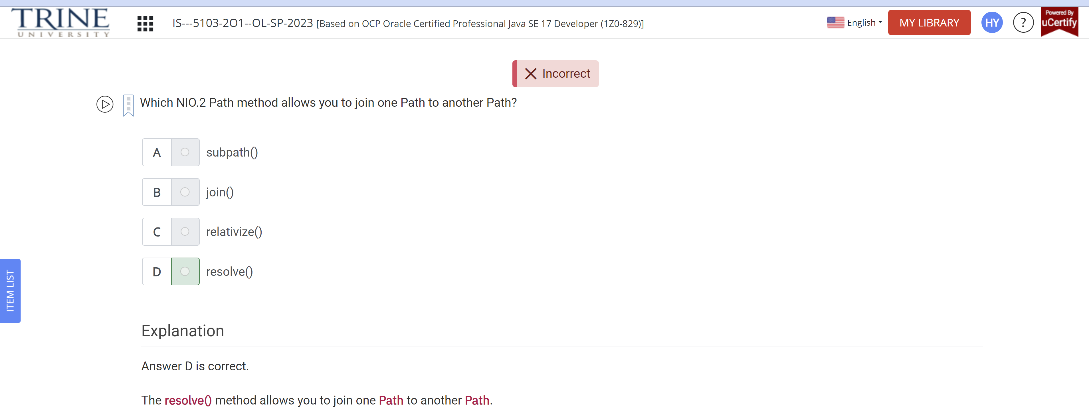

Identify the correct statement

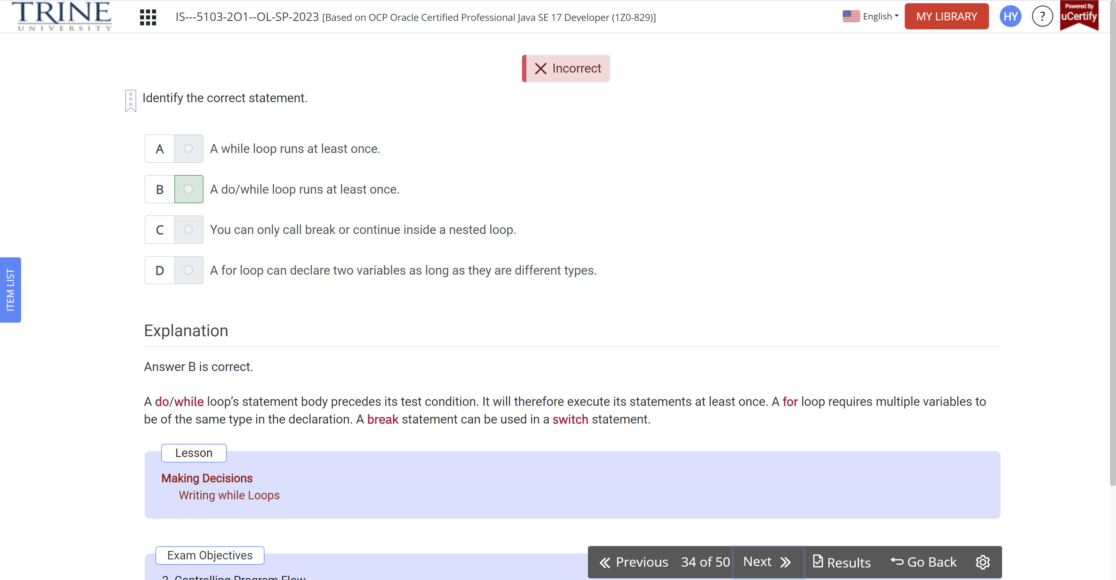

Suppose you have a module named com.vet. Where could you place the following module-info.java file to create a valid module?

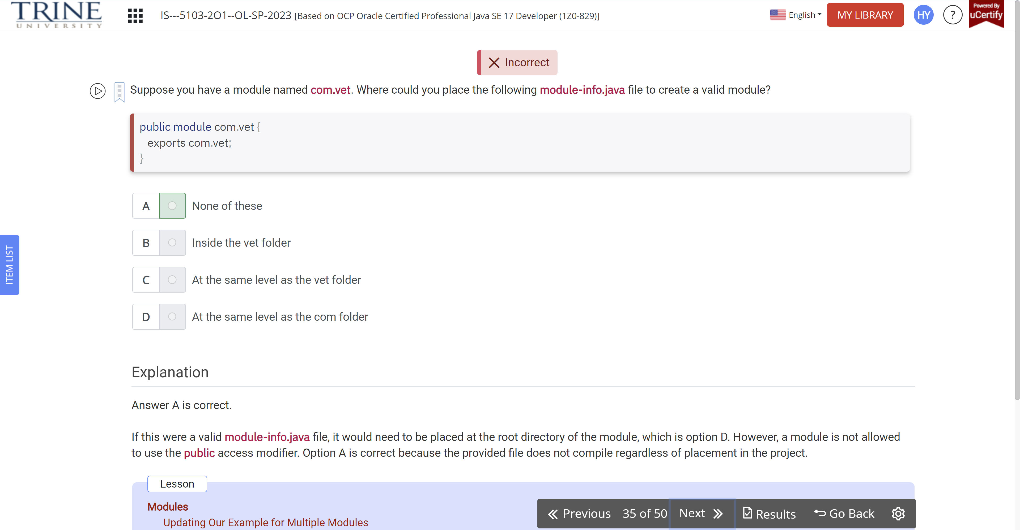

What is the result of compiling and executing the following program?

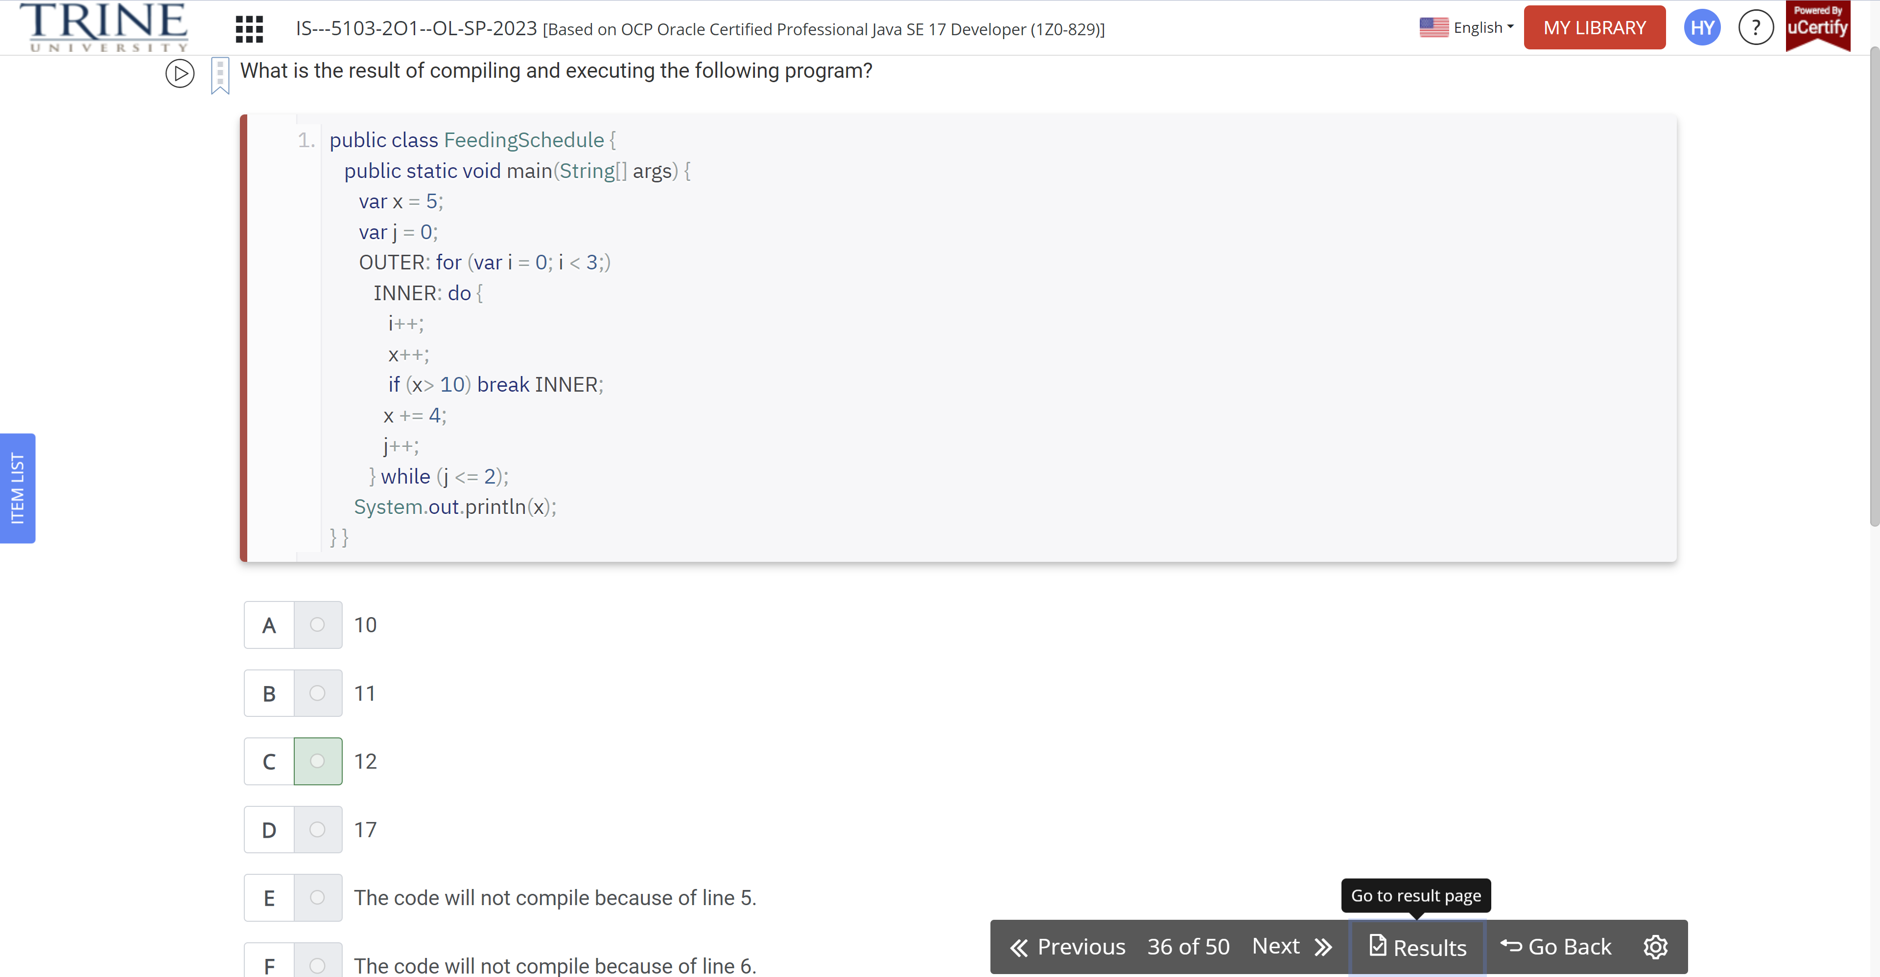

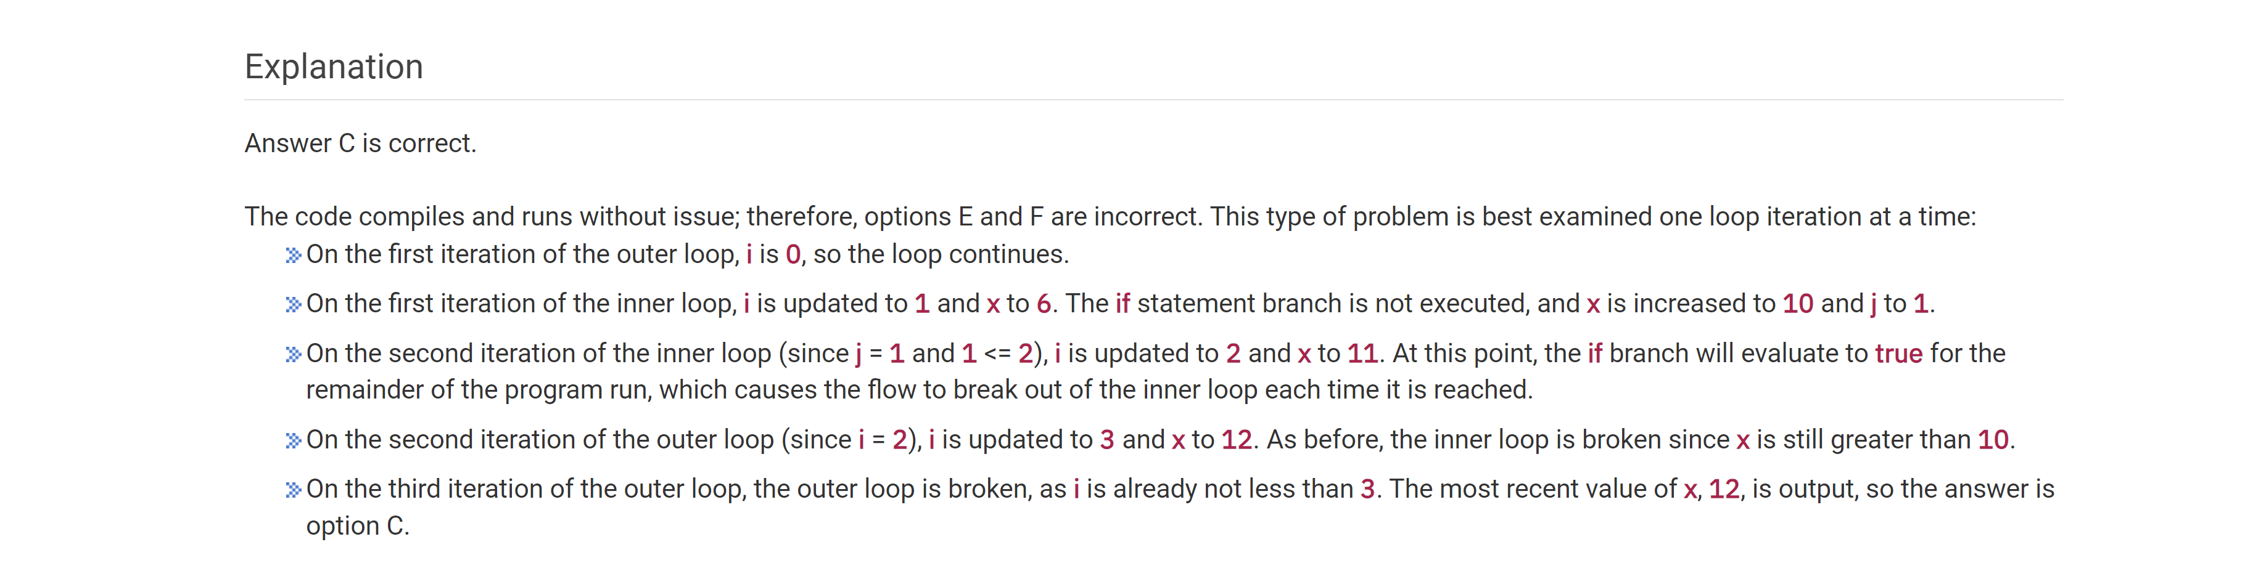

Which of the following features are configurable in a for statement that are not configurable in a for-each statement?

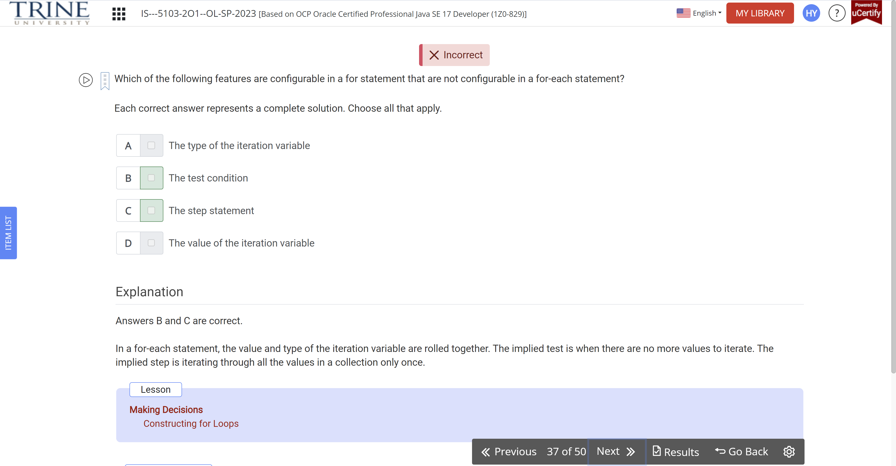

Which of the following lines can fill in the blank to print true?

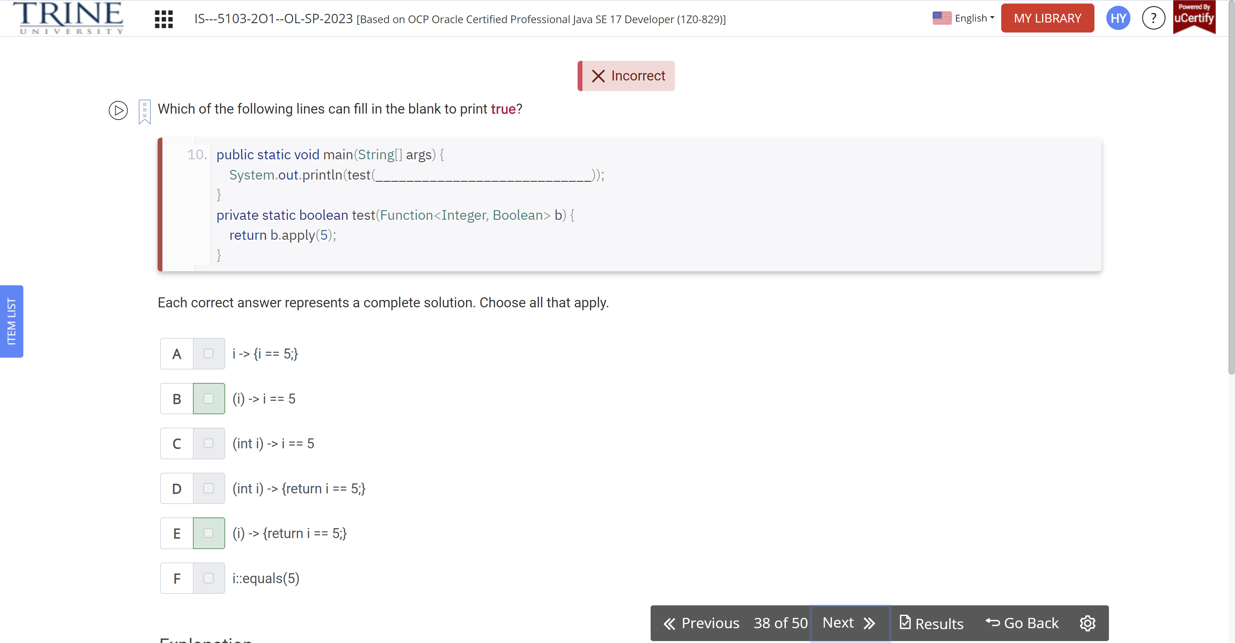

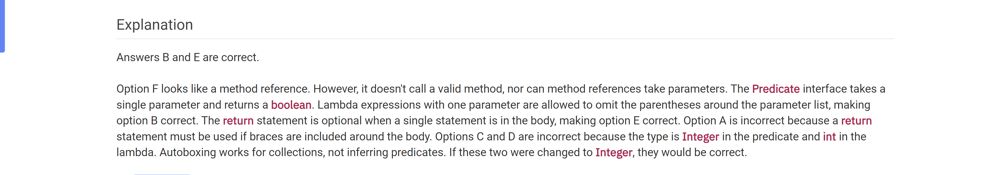

Which is not a SQL keyword?

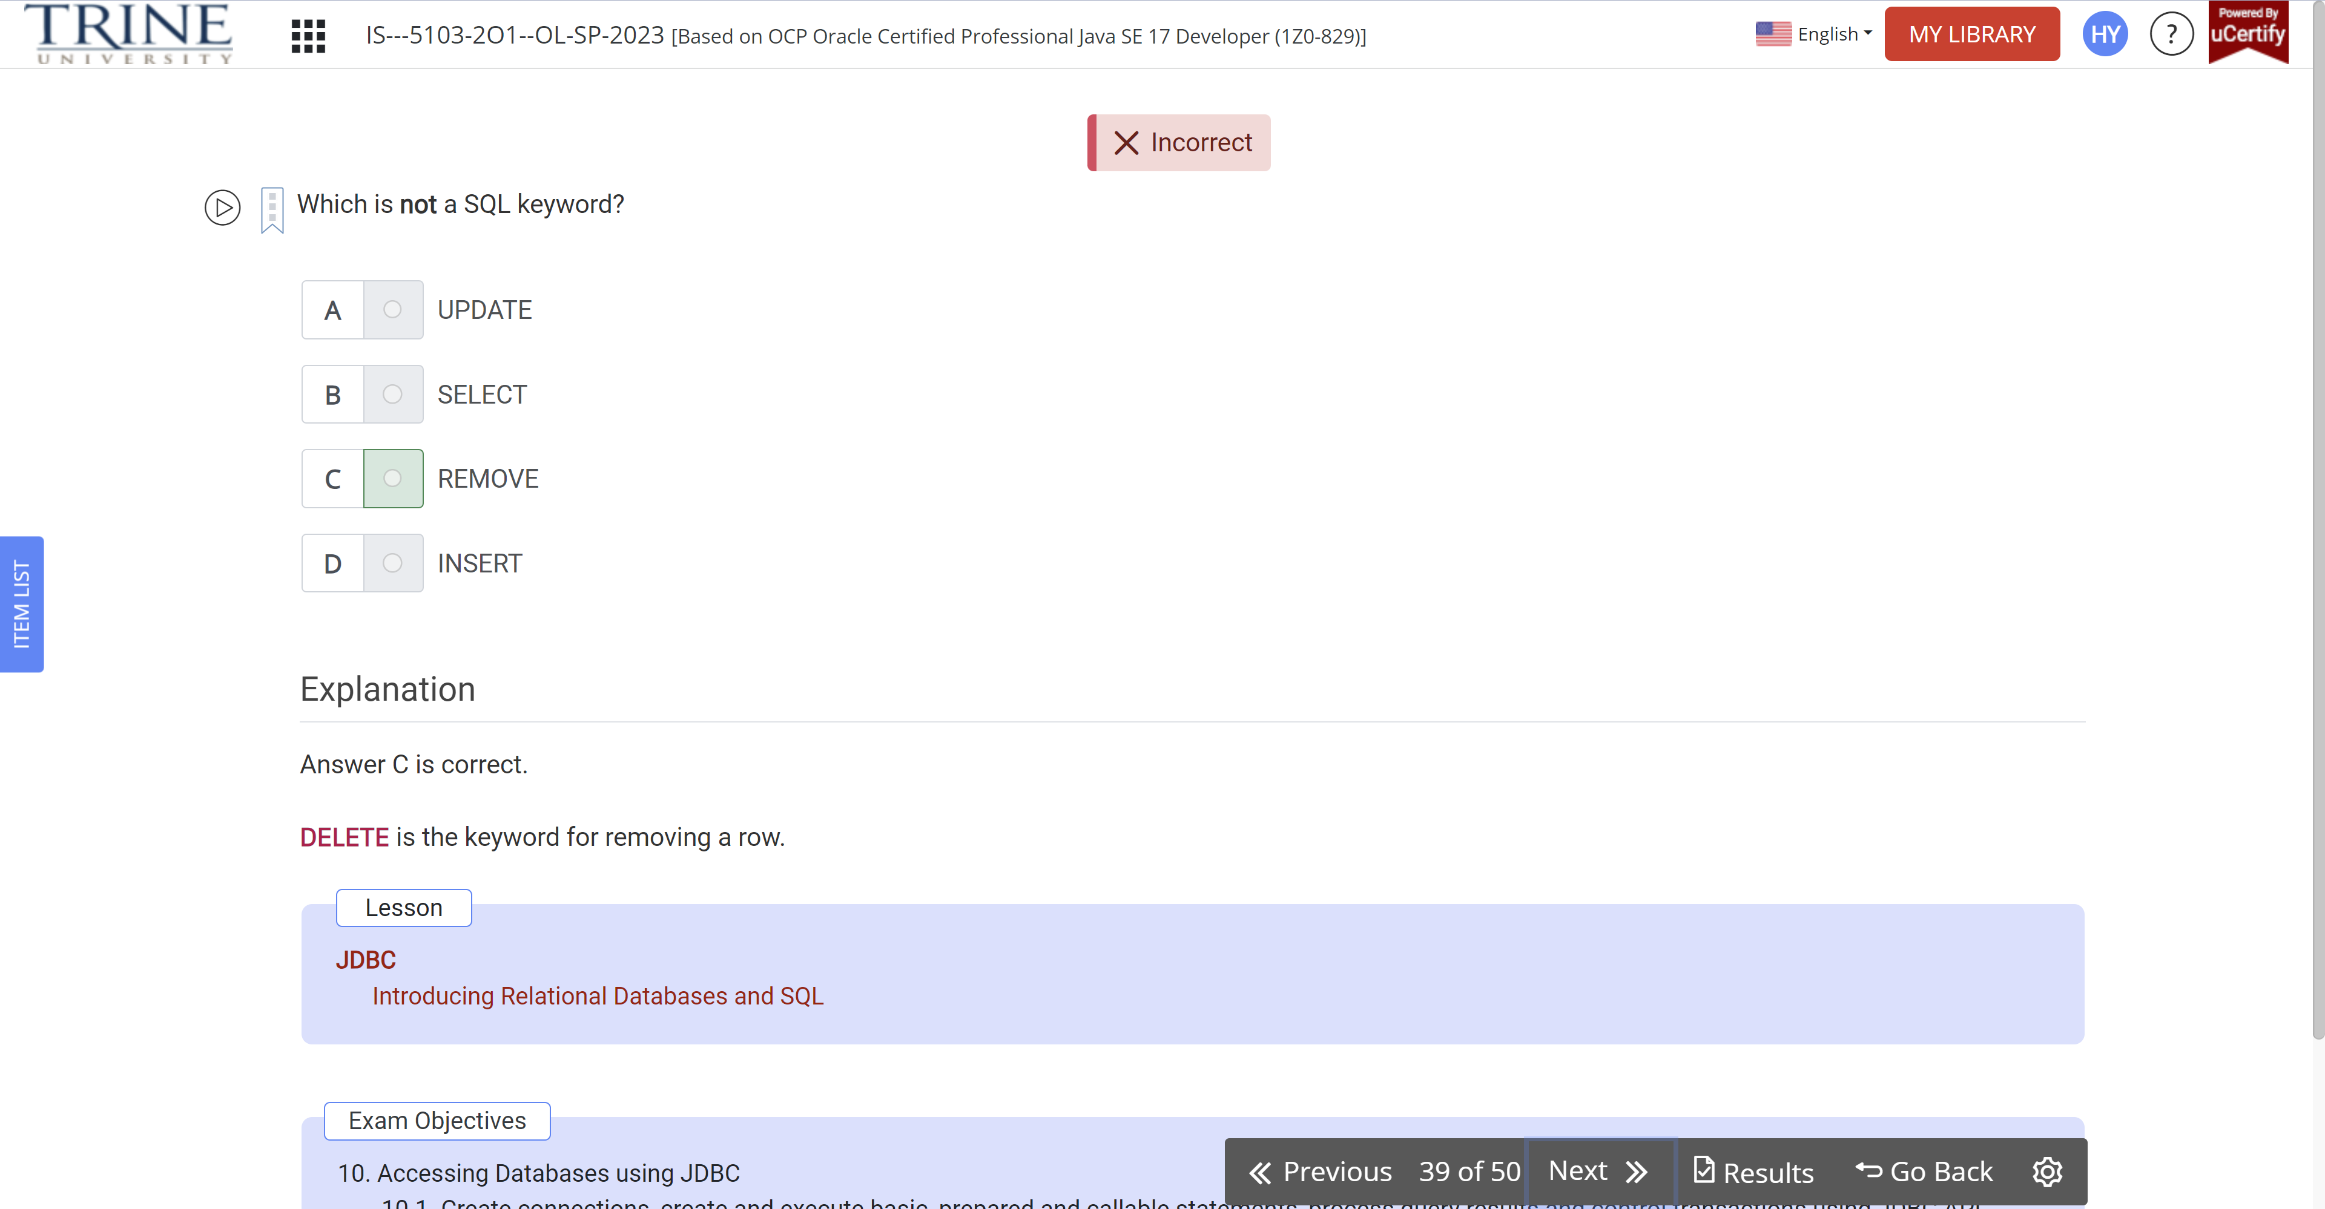

Which of the following types can be inserted into the blank to allow the program to compile successfully?

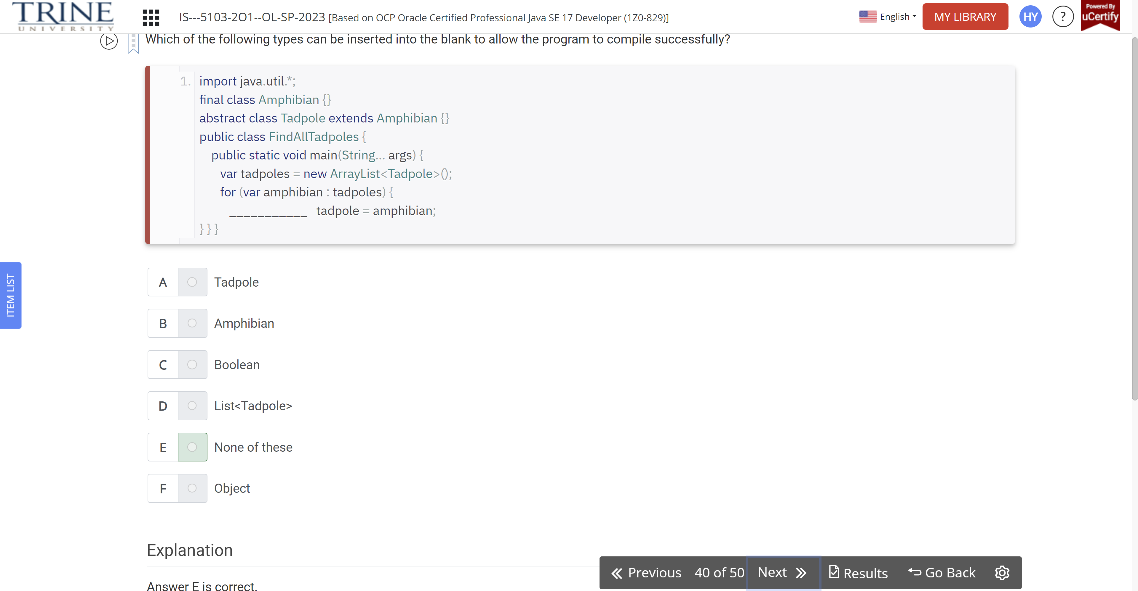

Which statement about the following method is true?

Public static void main (…)

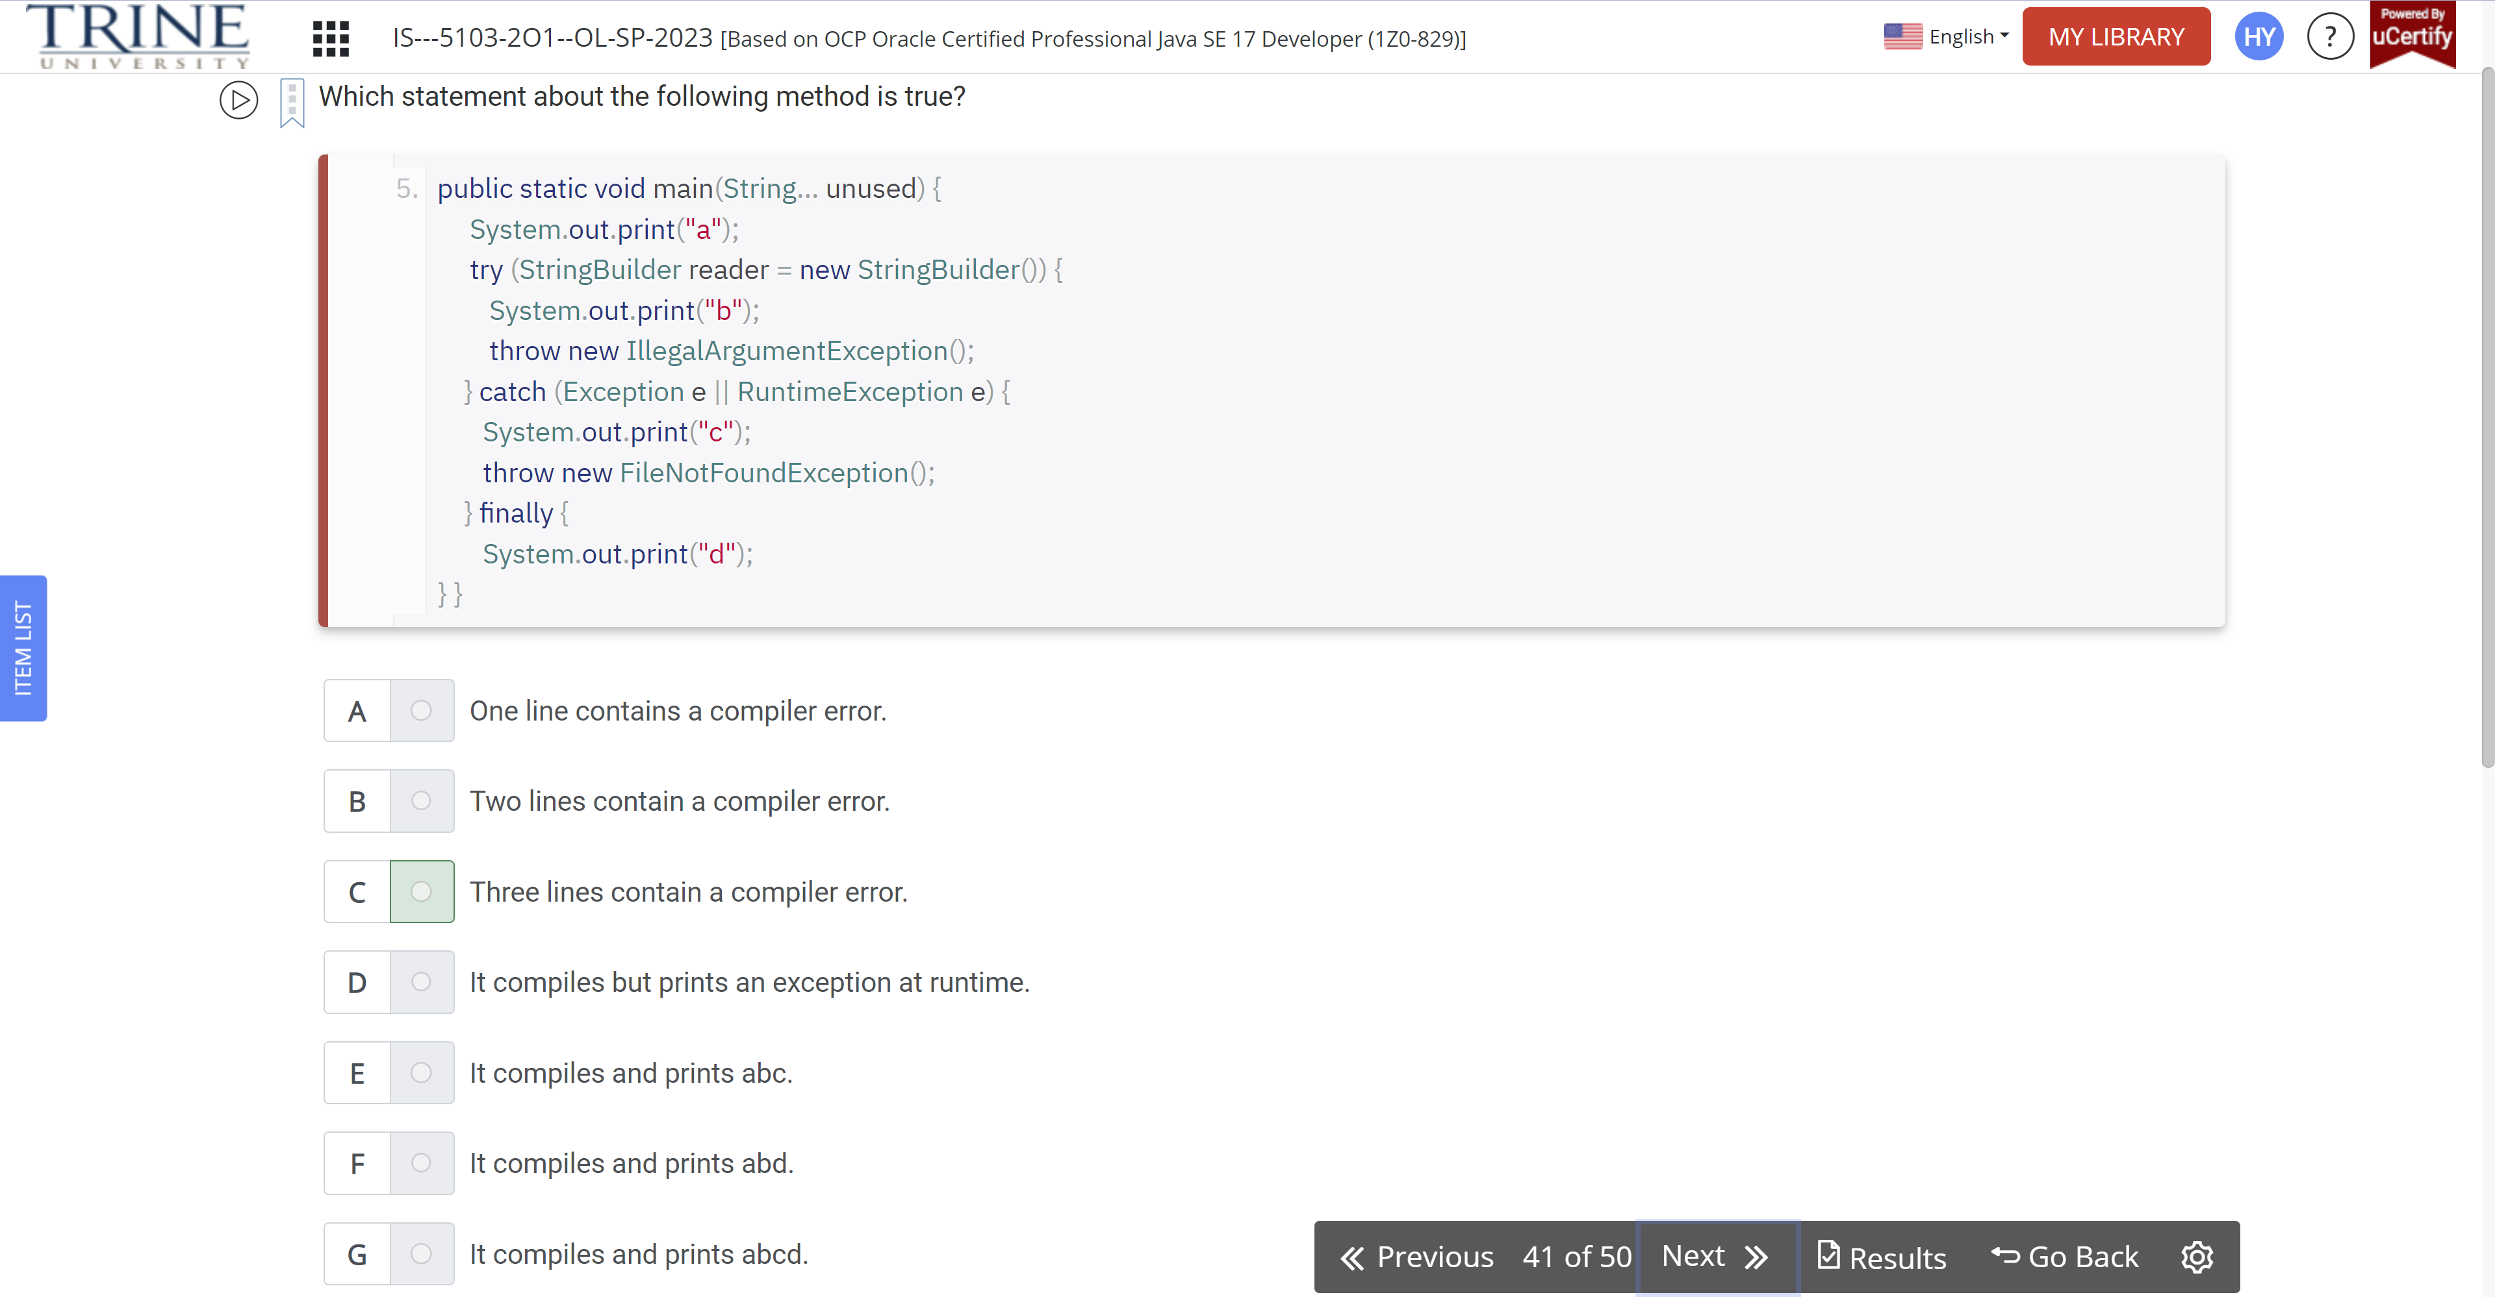

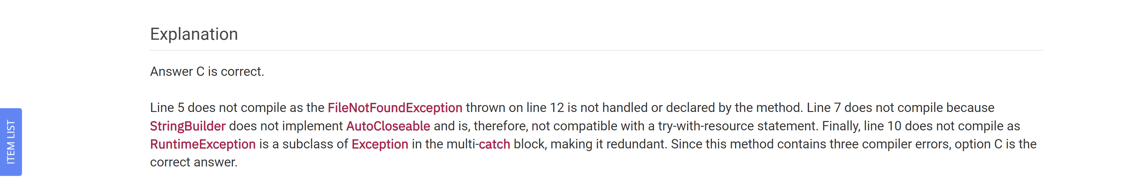

Which of the following statements are true if the table is empty before the code execution?

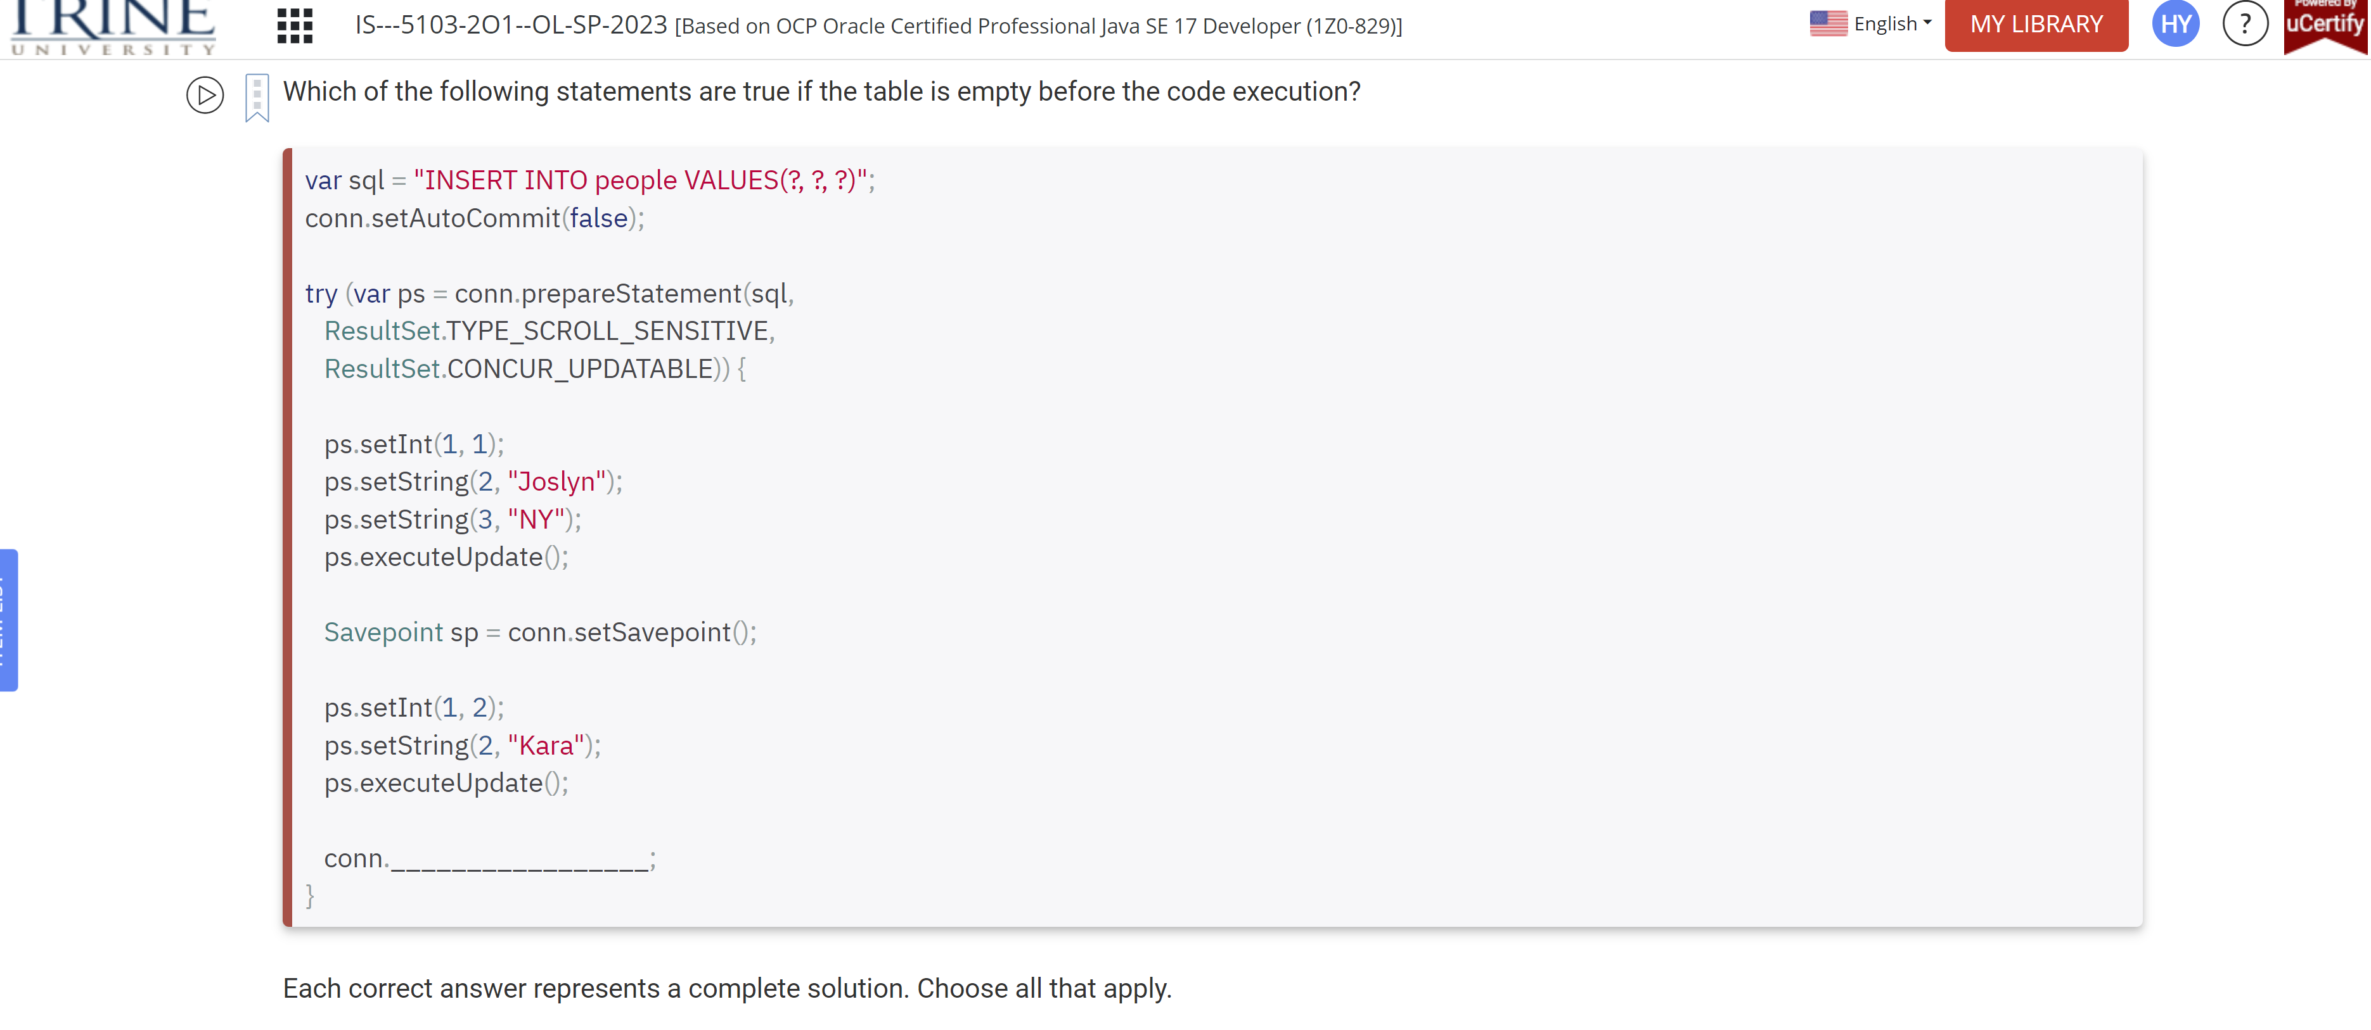

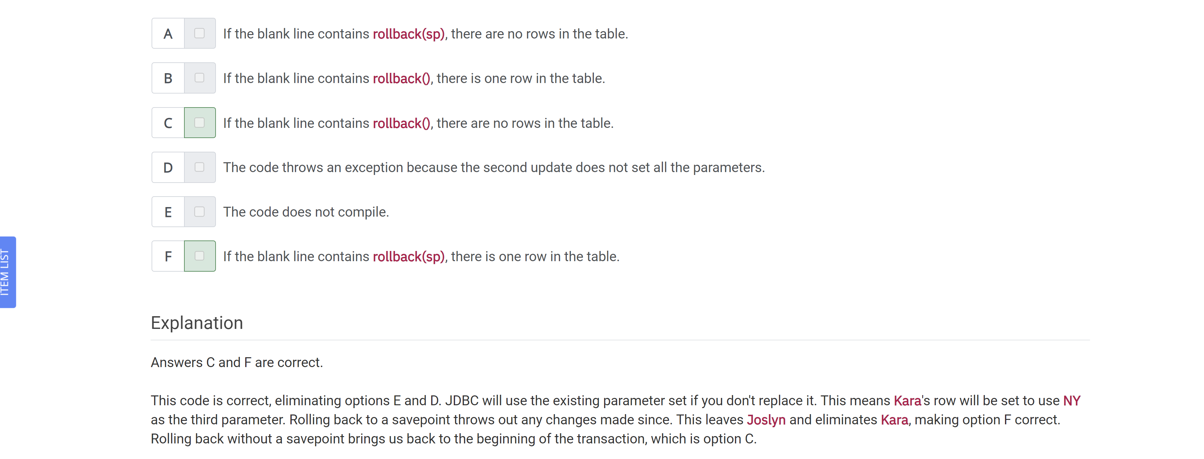

Assume that birds.dat exists, is accessible, and contains data for a Bird object, …

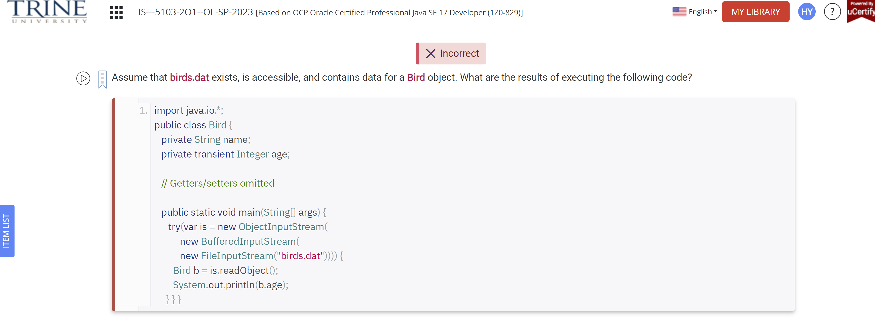

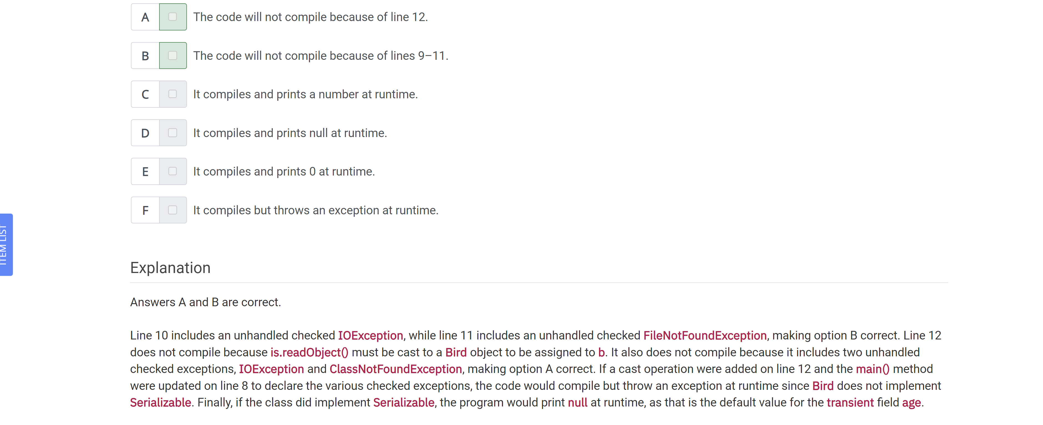

When creating a Locale, the country code is in uppercase. True

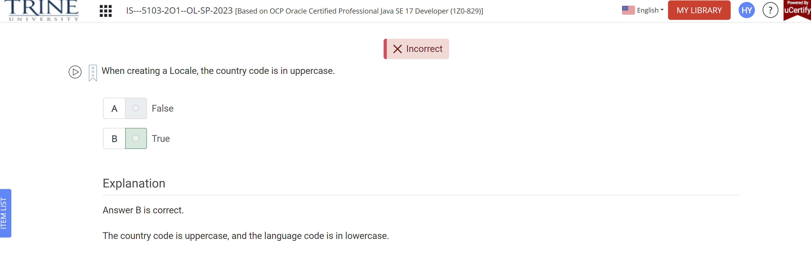

Which of the following statements can be used to exit a loop early?

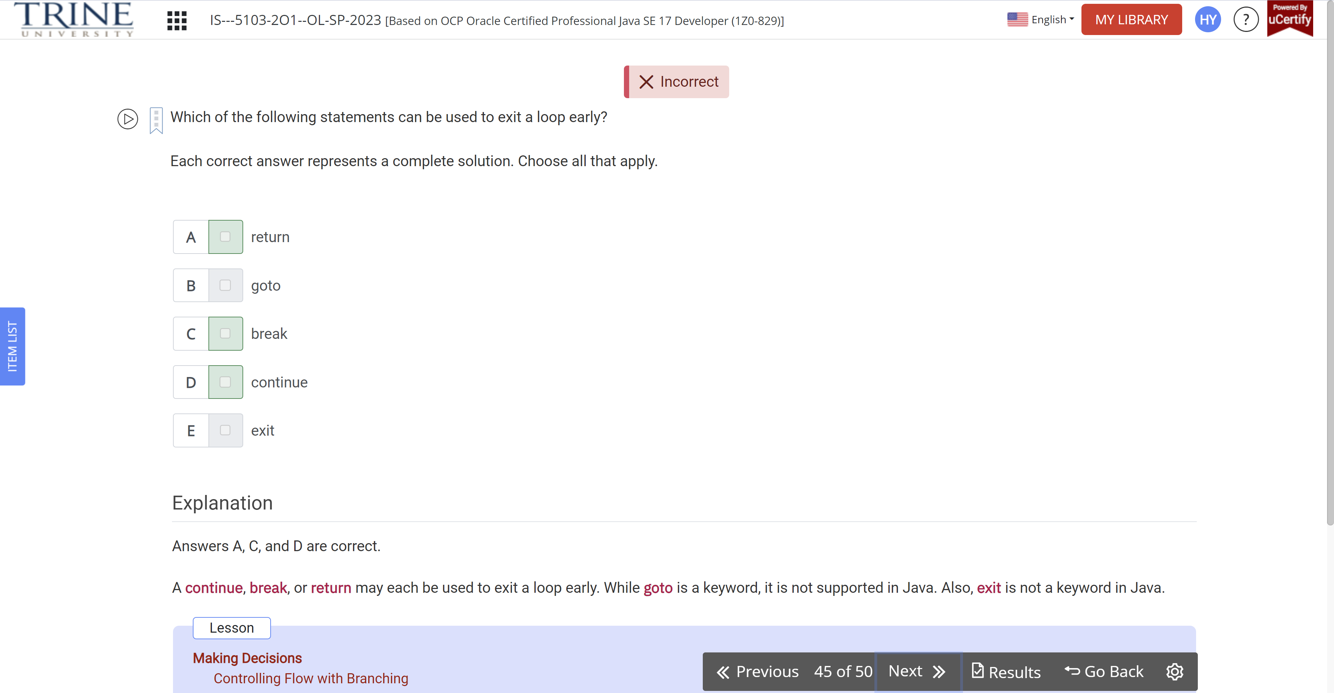

Which of the following expressions compile without error?

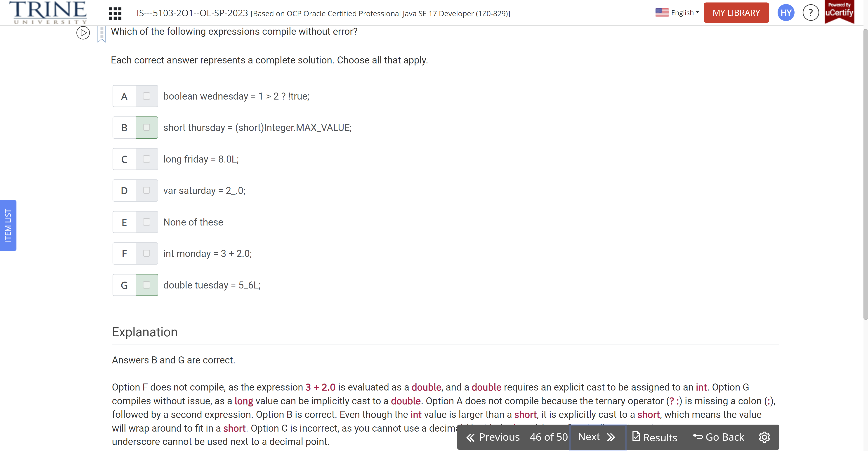

Which of the following statements can fill in the blank to make the code compile successfully?

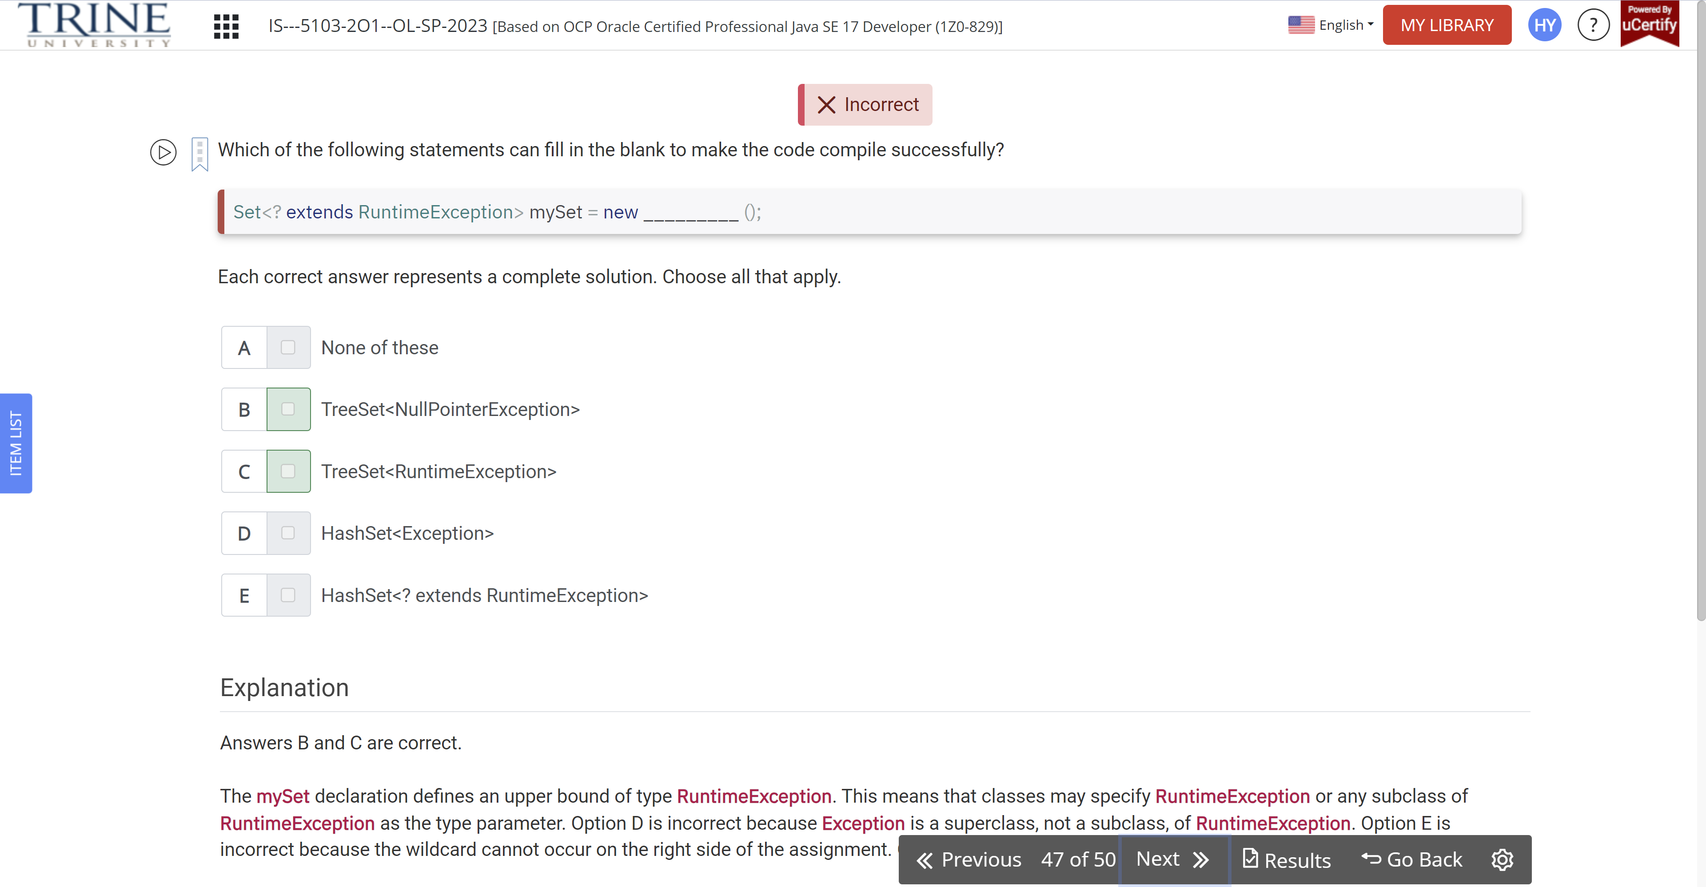

What interface is used to run SQL defined in the code with bind variables?

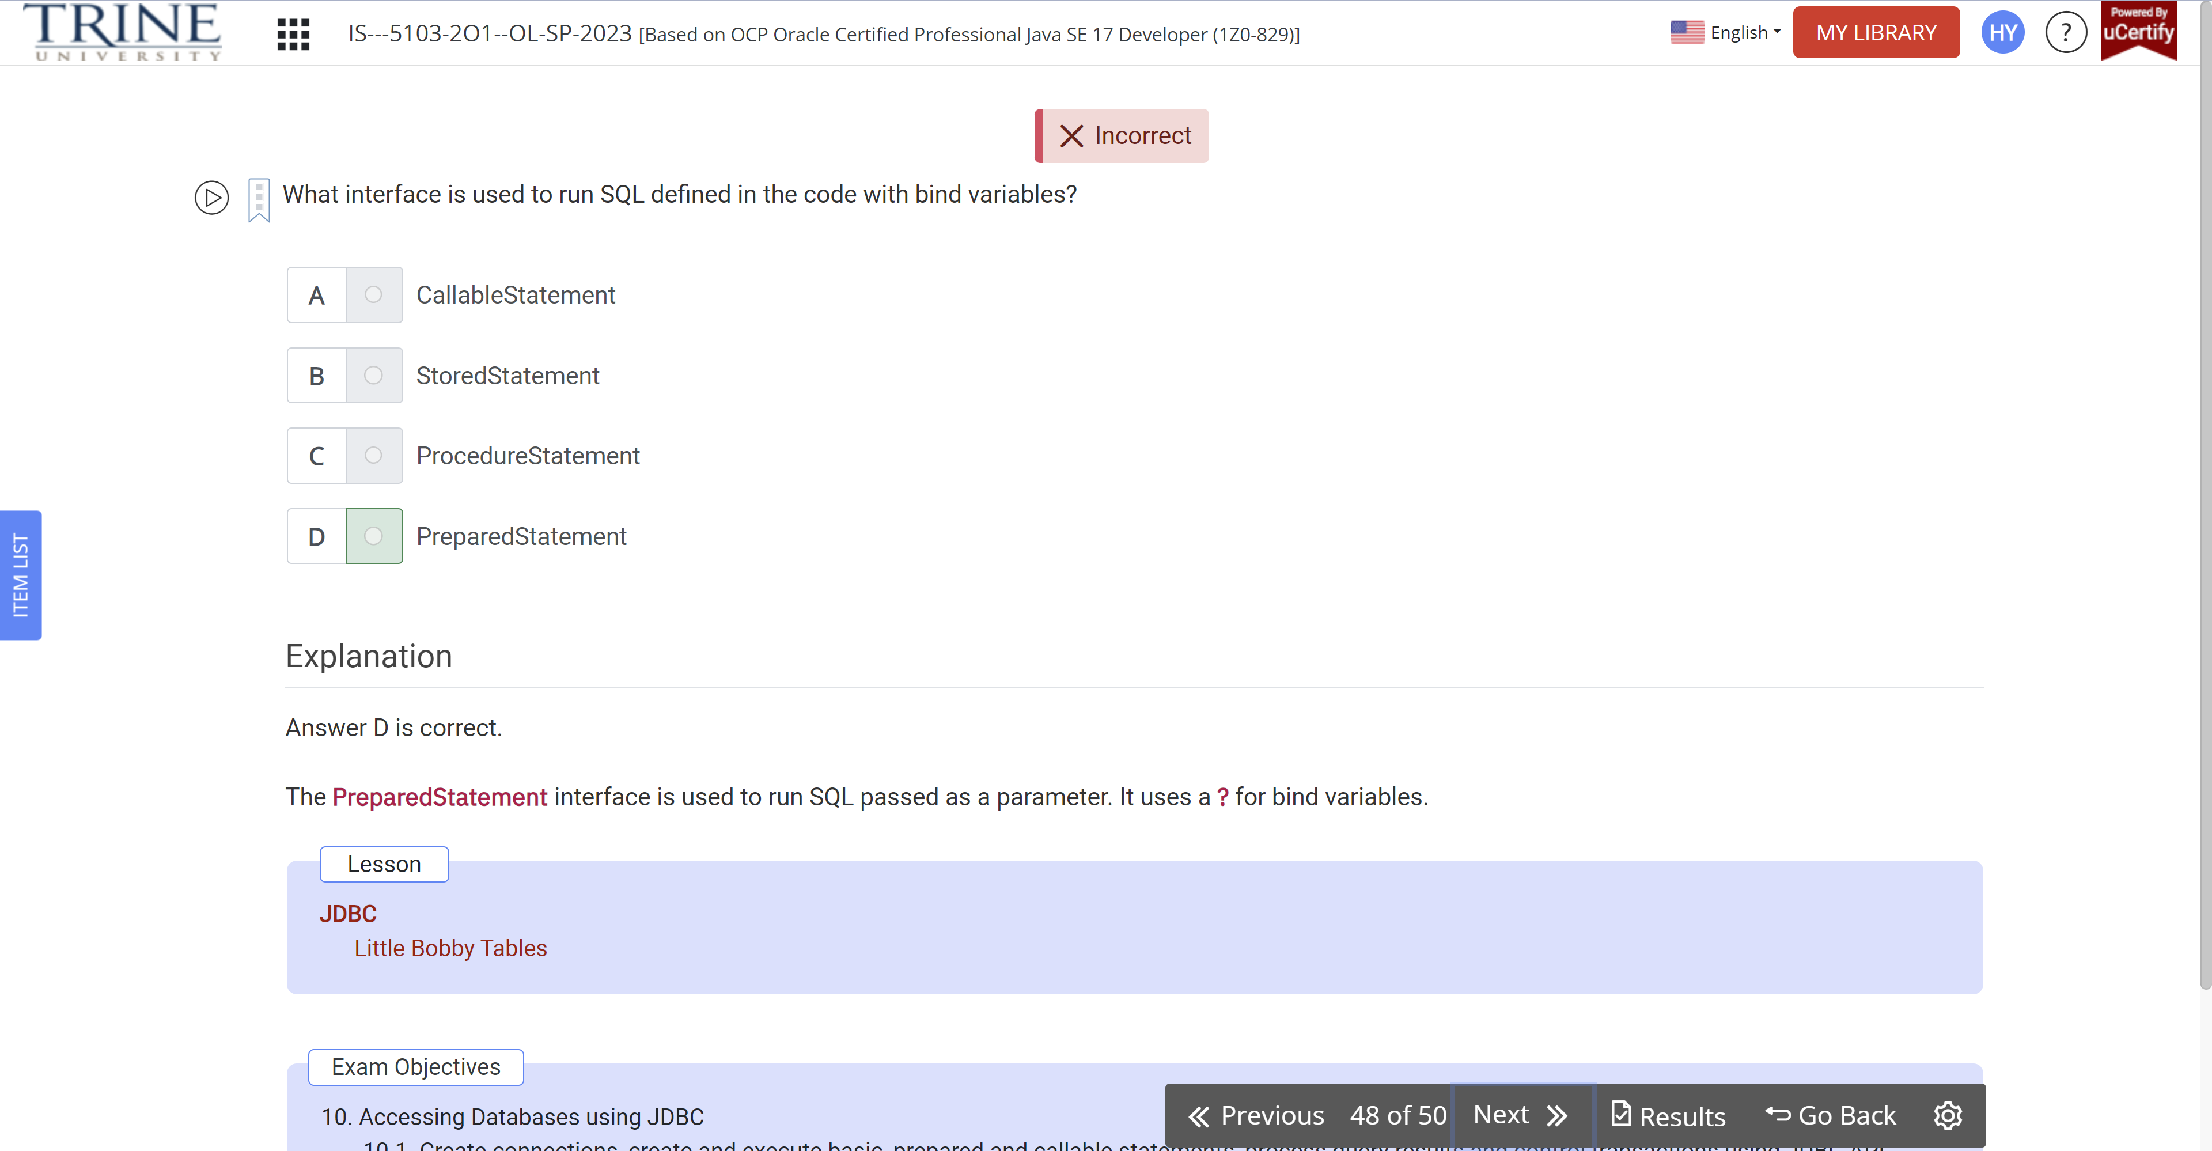

Which of the following can fill in the blanks in order to make this code compile?

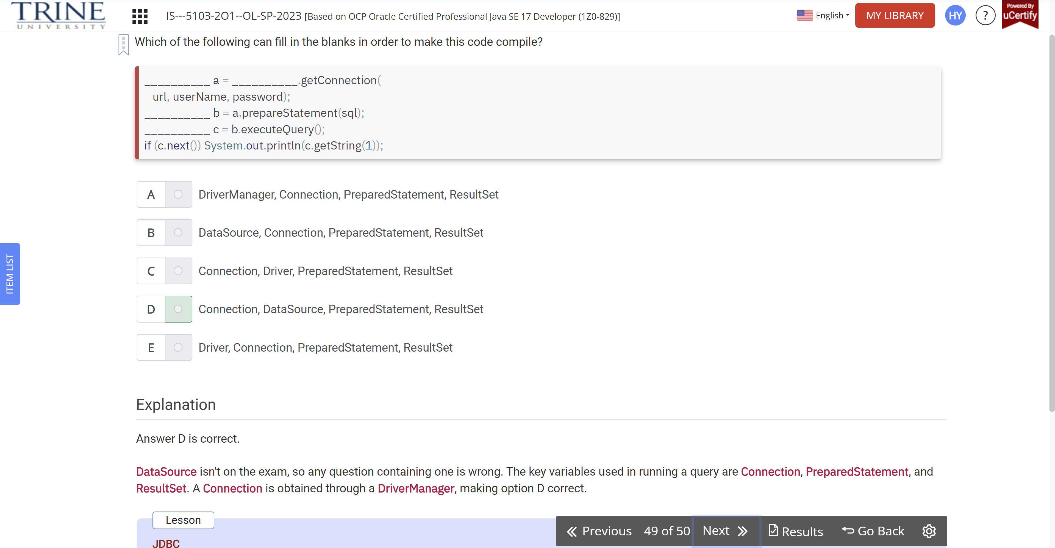

A property file resource bundle can only contain String values.

